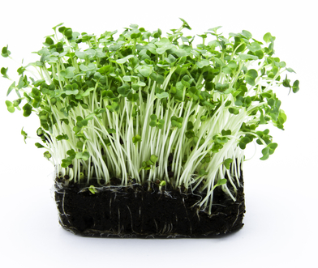
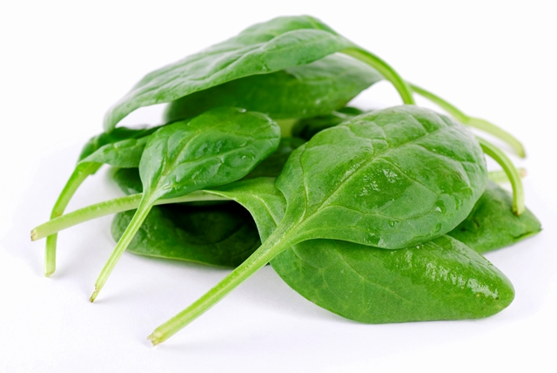
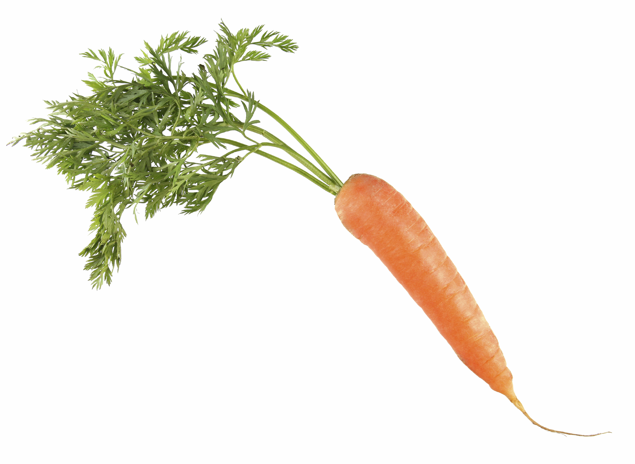
Completing the Grow the seasons Challenge
www.foodafactoflife.org.uk
© Food – a fact of life 2018
[Date]
[Name]

