Quick bao buns

Ingredients
Complexity: Medium
200g plain flour
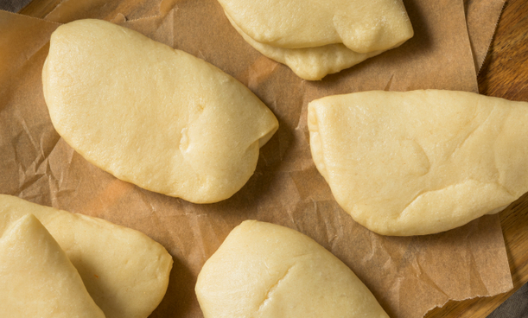
½ x 5ml spoon (½tsp) fast action dried yeast
2 x 5ml spoon (2tsp) caster sugar
½ x 5ml spoon (½tsp) salt
100ml (3fl oz.) warm water
25ml (0.8fl oz.) milk
1 x 5ml spoon (1tbs) sunflower oil
1 x 5ml spoon (1tsp) rice vinegar
½ x 5ml spoon (½tsp) baking powder

Equipment
Sieve, mixing spoon, measuring jug, rolling pin, chopstick or table spoon, pastry brush, baking tray, greaseproof paper, clean tea towel, large steamer.

Method
- Sieve the flour into a bowl. Add the yeast, sugar and salt. Stir well.
- Mix the warm water, milk, oil and vinegar in a jug. Add to the flour and stir well with a spoon.
- Bring the mixture together to form a dough. Place the dough onto a chopping board and sprinkle over the baking powder.
- Knead on a lightly floured work surface for around 10-15 minutes or until smooth.
- Divide the dough into 8 even sized buns.
- Use a rolling pin to roll out each ball, one by one, into an oval shape about 3-4mm thick. Brush a little oil over each of the ovals and the chopstick or spoon handle.
- Place the oiled chopstick or spoon handle in the centre of an oval. Fold the dough over the chopstick or spoon handle, then slowly pull out the chopstick or handle.
- Carefully place the buns on a lined baking tray, cover with a clean tea towel and leave to prove in a warm place for about 20 minutes.
- Heat a large steamer over a medium high heat. In batches, steam the buns for 12-15 minutes until puffed up.
- Prise open each bun and fill with your burger, sauces and toppings.
- Eat whilst they are still warm.
Did you know?
Bao buns, often filled with sweet and sour pulled meats are the Asian equivalent of a burger. Originally from Taiwan these steamed buns, sometimes made with rice flour, are now popular all over the world.

Top tips
- Fill with sweet sour pulled meats and vegetables.
- Use instead of a bun and fill with a burger and salad.

Food skills
- Sieve
- Sprinkle
- Knead
- Divide
- Roll out
- Brush
- Fold
- Steam
- Heat

