Fat aeration

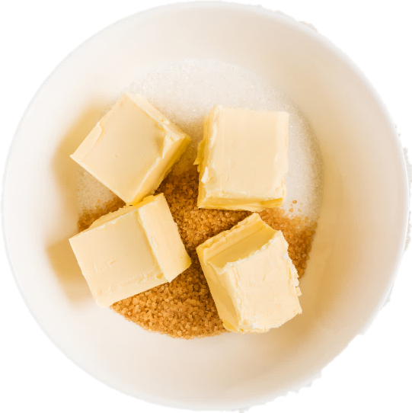
Learning
The aim of this session is to:
- demonstrate how fat aeration can create a light, fluffy texture in a food;
- show how selecting the right fat and temperature is important for the creaming method.

You will need:
- 150g butter;
- 300g granulated white or brown sugar;
- wooden spoon;
- 3 mixing bowls;
- knife;
- wooden spoon (or electric mixer).

Instructions:
- Before beginning the experiment, chop the butter into three evenly sized pieces.
- Keep one piece in the fridge (so it is hard), allow one to soften at room temperature and melt the third in the microwave or on the hob.
- Divide the sugar evenly between the mixing bowls (100g in each).
- Chop the hard butter into cubes and add to one bowl. Do the same for the room temperature butter in the second bowl.
- Finally, add the melted butter to the third bowl.
- Using a wooden spoon (or an electric mixer on medium speed) begin to cream the butter and sugar together.
- Observe the volume, lightness and colour of the final mixtures.

Questions
Think about these questions after you have completed the experiment:
- Which temperature of butter is best for incorporating the most air?
- Why might the other temperatures not work as well?
- What might happen if you used vegetable oil instead of butter?
- Why might mixing at high speed be less effective than at medium speed?

