Gingerbread people

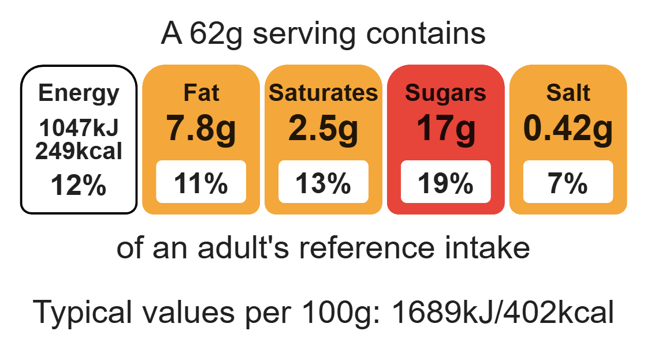
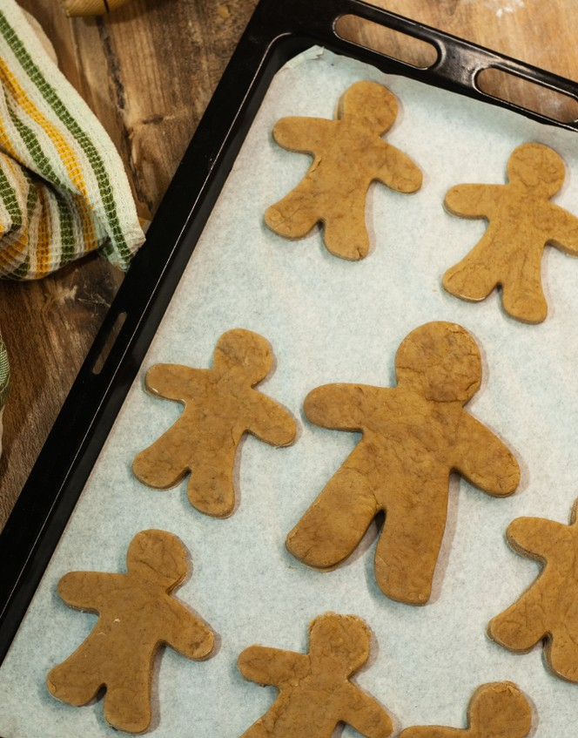

Ingredients (makes 6)

200g plain wholemeal flour
Complexity: medium

75g brown sugar

50g reduced-fat spread

Equipment

Baking tray

Weighing scales

Mixing bowl

Sieve

Small bowl

Fork

Small saucepan

Measuring spoons

Heat-resistant spoon

Rolling pin

Flour dredger (optional)

Biscuit cutters

Cooling rack

Piping bag

1 x 15ml spoon golden syrup

½ x 5ml spoon bicarbonate of soda

1 x 5ml spoon ground ginger

1 egg

Cherries or currants and icing to decorate

Method
- Preheat the oven to 180ºC or gas mark 4.
- Grease or line a baking tray.
- Sift the flour, ginger and bicarbonate of soda into a mixing bowl.
- Whisk the egg in a small bowl using a fork.
- Gently melt the spread, syrup and sugar together in a small saucepan. Do not allow to boil.
- Add the melted mixture and the beaten egg to the flour.
- Mix to form a soft dough.
- Allow the mixture to cool.
- Roll out the dough to 0.5 cm thick on a floured work surface.
- Cut into gingerbread shapes and carefully place on the baking tray.
- Decorate with currants or cherries.
- Bake for 8-10 minutes. Carefully remove from the tray and allow to cool thoroughly on a cooling rack.
- Pipe icing on top to decorate.

Top tips
- To make Christmas decorations, use a star or snowflake cutter. Make a hole in the top before baking and thread ribbon through once cooled. Hang on your Christmas tree or give as gifts.

Food skills
Weigh, measure, sift, whisk, melt, simmer and boil, mix, stir and combine, roll out, cut out, decorate and garnish, bake.

