Easy veg frittatas

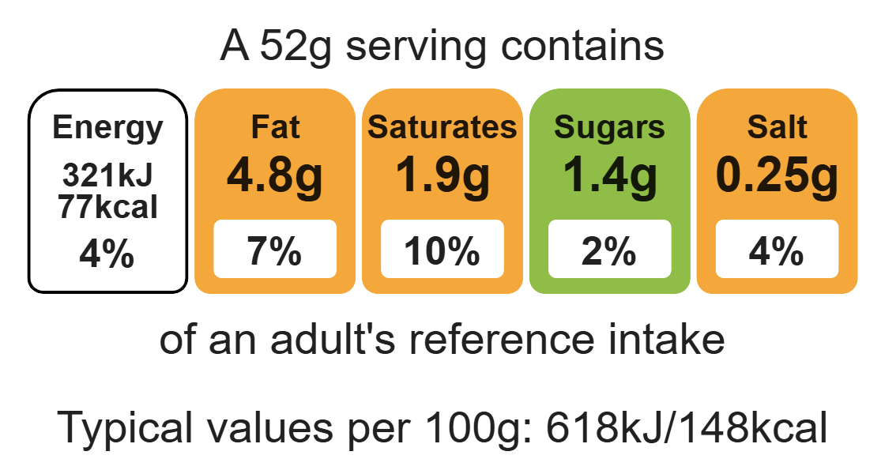

Complexity: low - medium

Ingredients (serves 6)

2 spring onions

Equipment

Chopping board

Sharp knife

Grater

Mixing bowl

Fork

Measuring jug

Non-stick muffin tin

50g reduced-fat cheese, e.g. Cheddar, Cheshire

Fresh coriander or chives

3 eggs

80g sweetcorn (canned or frozen)

40ml semi-skimmed milk

Black pepper

Spray oil or 1x10ml spoon of vegetable oil

Method
1. Pre-heat oven to 200°C or gas mark 6.
2. Prepare the ingredients:
- top, tail and slice the spring onions;
- grate the cheese;
- chop the fresh herbs.
3. Crack the eggs into a bowl and whisk with a fork.
4. Add the milk to the bowl and mix well.
5. Stir in the cheese, fresh herbs and black pepper.
6. Spray the muffin cases or muffin tin lightly with oil.
7. Divide the vegetables equally between the 6 cases.
8. Pour over the egg, milk and cheese mixture.
9. Bake in the oven for 15-20 minutes, until the egg is cooked.

Top tips
- Turn up the flavour: Try a variety of fresh or dried herbs and spices, or different type of cheese such as red Leicester, Stilton, or feta.
- Reduce food waste: Use up any leftover vegetables like peppers, mushrooms, spinach or beetroot.
- Vary your protein: Add chopped cooked meat, chicken or fish to the frittatas.

Food skills
Weigh, measure, cut, chop, slice, dice and rim, grate, whisk, mix, stir and combine, portion/ divide, bake.

