Session 8: Deli salads
Welcome
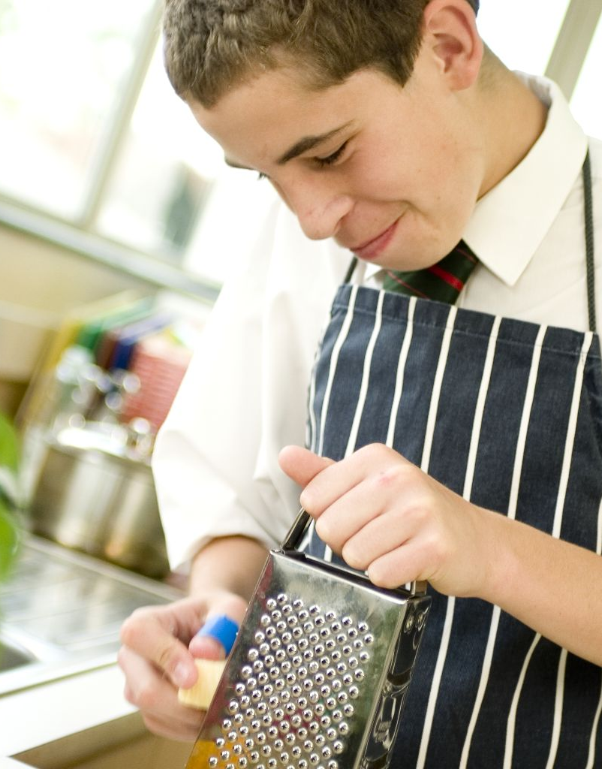
This session is about creating a deli-style salad using a range of different ingredients. Students will be presented with the opportunity to cook a range of starchy foods, while simultaneously preparing other ingredients for their salad. This will test their organisational skills in the kitchen. It also challenges students to assemble and present their salad attractively. The session revisits and embeds essential knife skills which were introduced throughout sessions 1-5. It also provides you with the opportunity to assess students’ practical capability. You could use the practical observation sheet to help.

During this session, students will make either a vegetable couscous salad or a layered pasta salad. These have been chosen as they involve the preparation of a starchy food, i.e. couscous or pasta, as well as a range of other ingredients. Although not included, you may wish your students to make their own dressings, if time permits. The couscous salad is easier to make. You may wish to challenge the students by substituting the couscous for potatoes, noodles or rice which they must cook on the hob.

There is lots of room for students to be creative, selecting different types of ingredients that could be combined into the dishes. You could get your students to use the vegetable couscous or layered pasta salad recipe writing frames before cooking to develop their own ideas. The students’ own recipe creations could then be used in this session.

If you have an established lesson plan and/or recipe, which supports the aims and objectives of this session, feel free to use it instead. Look at the support materials provided within this session as they support this activity and may well be useful in your own lessons, e.g. worksheets, PowerPoint presentations.

This session can act as a stand-alone lesson, focusing on salad preparation and organisational skills. Alternatively, it could be integrated into a series of lessons, e.g. exploring different types of starchy foods, as well as fruits and vegetables, which could be combined into exciting salads.

Aims and objectives

Aim
For students to:
- develop an appreciation of appearance, odour, texture and taste.

Objectives
Students should be able to:
- measure ingredients;
- prepare ingredients, e.g. slicing, dicing, grating;
- cook a starchy food, e.g. couscous or pasta;
- combine ingredients into a deli-style salad;
- use the hob safely, if appropriate;
- make a salad, e.g. vegetable couscous or layered pasta.

Cooking session
Two cooking session plans, based on the Licence to Cook recipes are supplied within this session.

If you have your own tried and tested couscous or pasta salad recipe, feel free to use it instead. In addition, you may wish to make other types of deli-salads, perhaps based on potatoes, rice or noodles.

Each plan refers to aspects of healthy eating, wise food shopping and food safety and hygiene which are themes which run through each session.

Before the cooking session
There are a number of factors that you need to consider before the cooking session. More detailed guidance is available in the Cooking session guide.

You will need to consider:
- Ingredients: who will be providing the ingredients and where will they be stored?
- Recipe: are pupils going to use a printed-out copy or follow instructions on an interactive whiteboard?
- Equipment: is all the equipment needed for the session available, clean and in good working order? Check that all the cooker hobs are clean. If you are making the couscous recipe, you will need kettles for the students to share. If you are cooking pasta, ensure that there are enough colanders.
- Aprons: do you have enough and are they clean?
- Hair: do you have ties/bands for long hair?
- Containers: will students be able to take away the salad they make? If so, in what?
- Waste: do you have adequate disposal facilities, including recycling or composting?
- Cooking area: is it clean and ready to use?

Differentiation and inclusion
Before this practical session, you will need to consider the age, ability, previous experience and any special requirements of your students. This will determine recipe selection, any advanced ingredient preparation and equipment used.

Do any of your students need:
- ingredients pre-measured or partly prepared, to allow them time to complete the recipe?
- support draining the hot water from the pasta?
- to omit some vegetable ingredients to make the recipe easier?
- to follow different recipes? The vegetable couscous recipe is easier than the layered pasta salad.
- challenging, perhaps by modifying the couscous recipe to use rice, noodles or potatoes instead?
- an extension activity, such as making their own dressing?

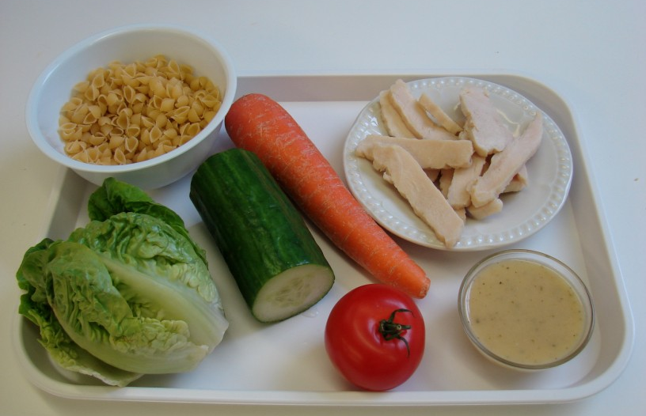
Demonstration
During the session you will be demonstrating how to cook couscous or pasta. For the pasta, it will be important to review how to drain away the boiling hot water safely from the saucepan. You may wish to have a saucepan ready to demonstrate this aspect. You may wish to remind students of the Bridge hold and Claw grip cutting techniques.

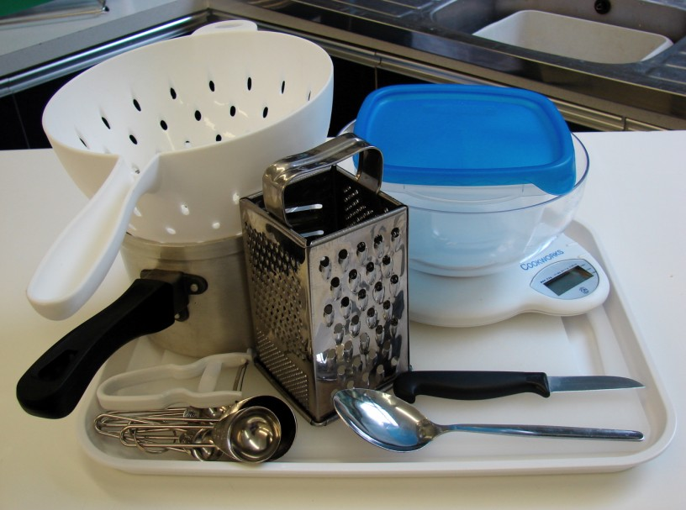
Ensure that you have all the ingredients and equipment you need before the session, perhaps on trays for ease, for your demonstration.

Think about:
- describing the ingredients and equipment used;
- highlighting the safe use of the knife;
- showing how to cook and drain pasta, or make couscous;
- ensuring that students have followed and understood the method.

More detailed guidance is available in the Demonstrating guide.

Risk assessment

The two cooking session plans and recipes highlight a number of different hygiene and safety issues which need to be considered before, during and after the cooking session.

Before the cooking session, you will need to assess these risks in relation to the number of students being taught, as well as their experience, and consider measures that can be put into place to manage the risk. Below are examples of potential risks, along with preventative measures.

Vegetable couscous salad
Potential risk | Measure | Likelihood
Dirt or food poisoning bacteria present on raw food, causing cross contamination | Wash vegetables before use | Low
Cuts from using a knife unsafely | Demonstrate safe use of knives and monitor students’ use | Med
Scalds from hot water in kettle | Demonstrate safe use of the kettle and monitor students’ use | Low/Med

Layered pasta salad
Potential risk | Measure | Likelihood
Perishable foods are not stored correctly, leading to contamination | Ensure that salad and cooked meat is kept in the refrigerator before use and that non-perishables are kept in clean, dry cupboards, e.g. dried pasta | Low
Scalds from hot water while draining pasta | Demonstrate how to drain hot water away from pasta and monitor students’ use | Low/Med

Time
The session plans are based on a 60 minute session.

If you have less time available, you will need to modify the session plan to better suit your circumstances. For example, within this session you might:
- demonstrate key aspects from the recipe, rather than every stage;
- have ingredients pre-measured and/or pre-prepared, e.g. grated carrot;
- reduce the number of vegetables used in the salads;
- use ready cooked pasta, potatoes, rice, noodles or couscous;
- allow students to work with a partner.

During the lesson
Time (mins) | Activity: Vegetable couscous salad | Equipment/ Resources
0 | Registration.  Explain to the students that they will be making vegetable couscous salad. Go through the aims and objectives for the lesson. | PowerPoint  Vegetable couscous salad recipe
5 | Gather the students around a demonstration area, with your tray of ingredients and equipment. Ensure that all students have their apron on, hair tied back and hands washed.  Briefly talk through the recipe – note your expectations, for example:  * measuring accurately;  * using the kettle safely to pour hot water;  * preparing the couscous;  * using knife skills to prepare a range of vegetables, i.e. Bridge hold and Claw grip;  * assembling the final salad;  * being hygienic and safe when preparing food. | Aprons  Demonstration ingredient and equipment tray
 | Demonstration  * Place out the mixing bowl, measuring jug, spoon, chopping board and vegetable knife.  * Measure the boiling water from the kettle. Pour slowly and carefully, paying attention to the amount and being safe. Add the stock powder and whisk together.  * Place the couscous into the mixing bowl and carefully pour the hot stock over. Make sure it is poured over slowly to avoid splashing. Fluff the couscous with a fork and move to one side.  * Recap the Bridge hold and Claw grip cutting techniques using the tomato, cucumber, pepper, parsley and apricots.  * Demonstrate how to snip the spring onion into chunks using scissors safely.  * If you have time, show students how to combine everything together with the dressing. | Aprons  Demonstration ingredient and equipment tray
15 | Ensure that all students wash their hands. Allow them to start making their vegetable couscous.  During this time, circulate the room to ensure that students are preparing ingredients and using the kettle safely. In this time, students should:  * measure their ingredients;  * use the kettle to boil water for the couscous;  * make up stock;  * add the stock to the couscous;  * use a range of knife skills to prepare the vegetables;  * stir in the vegetables, apricots and dressing into the couscous. | Basic equipment  Kettle  Ingredients

35 | During this time students should be washing up, cleaning work surfaces and putting away equipment.
50 | Give a 5 minute time warning.  Remind students that all washing up should be completed, work surfaces should be clean and their vegetable couscous should be served in a container.  Circulate the room, ensuring that sinks are clean and equipment is put away properly.
55 | Plenary  Pose the following questions to the students:  * What were the main skills demonstrated today?  * Name 5 other vegetables that could be used.  * What might this be served with to make a light lunch or an evening meal?
60 | Finish

After the session
Check that the room is clean and tidy. Students should leave the room as they find it.
The vegetable couscous salad may need to be refrigerated until the end of the school day, if so, ensure that each container is covered and clearly labelled with the student’s name and group. The refrigerator should be between 0-5ºC.

If the same students are with you for another cooking session in the next few days or week, remind them of the ingredients and/or containers they need to bring, if appropriate. You may wish to provide students with recipes or writing frames.

During the lesson
Time (mins) | Activity: Layered pasta salad |  | Equipment/ Resources
0 | Registration.  Explain to the students that they will be making layered pasta salad. Go through the aims and objectives for the lesson. |  | PowerPoint Layered pasta salad recipe
5 | Gather the students around a demonstration area, with your tray of ingredients and equipment. Ensure that all students have their apron on, hair tied back and hands washed.  Briefly talk through the recipe – note your expectations, for example:  * measuring accurately;  * using the hob safely;  * cooking, draining and cooling the pasta safely;  * using knife skills to prepare a range of ingredients – while pasta is cooking/cooling;  * layering the salad;  * being hygienic and safe when preparing food. |  | Aprons  Demonstration ingredient and equipment tray
 | Demonstration  * Show students how to switch on the hob. If you have electric and gas hobs, you will need to show them both types.  * Bring a saucepan of water (3/4 full) to the boil. You may wish to use boiling water from a kettle for speed. When rapidly bubbling, add the pasta. Adding the pasta will reduce the temperature of the water, and the boiling with subside. Allow the water to rapidly boil once more, then reduce the heat allowing the pasta to simmer.  * While the pasta is cooking, place out the chopping board and vegetable knife.  * Recap the Bridge hold and Claw grip cutting techniques using the lettuce, tomato, cucumber and carrot (this will also need peeling).  * Check that the pasta is cooked – it should have change colour and be plump and soft to the touch (with a spoon). |  | Aprons  Demonstration ingredient and equipment tray
0 | * Demonstrate how to safely drain the hot water away from the pasta. Pace a colander in a sink, removing the washing-up bowl first. Using two hands carefully start to pour the water and then the pasta slowly into the colander – this helps to avoid splashes. Keep the saucepan steady as your pour. When the steam has disappeared, turn on the cold tap and use the colander by the handle to rinse the pasta under the cold water. Place the colander on top of the saucepan so that water does not drip on the floor when you move it.  * If you have time, show students how to layer the salad – although you may wish to allow them to use their own creativity. |  | PowerPoint Layered pasta salad recipe
15 |  | Ensure that students all wash their hands. Allow them to start making their layered pasta salad.  During this time, circulate the room to ensure that students are preparing ingredients and using the hob safely. In this time, students should:  * measure their ingredients;  * cook, drain and chill the pasta;  * use a range of knife skills to prepare the other ingredients;  * layer the salad attractively in a container. | Ingredients  Basic equipment  Colanders  Saucepans
30 |  | Check that all students either have the pasta cooking or that it has been drained. Monitor students draining the pasta. During this time students should be washing up, cleaning work surfaces and putting away equipment.
50 |  | Give a 5 minute time warning.  Remind students that all washing-up should be completed, work surfaces should be clean and their layered pasta salad should be in a container.  Circulate the room, ensuring that sinks are clean and equipment is put away properly.
55 |  | Plenary  Pose the following questions to the students:  * What were the main skills demonstrated today?  * Name 6 other ingredients that could be used in the salad?  * How could this recipe be modified to make it suitable for a vegetarian?
60 |  | Finish

After the session
Check that the room is clean and tidy. Students should leave the room as they find it.

The layered pasta salad may need to be refrigerated until the end of the school day, if so, ensure that each container is covered and clearly labelled with the student’s name and group. The refrigerator should be between 0-5ºC.

If the same students are with you for another cooking session in the next few days or week, remind them of the ingredients and/or containers they need to bring, if appropriate. You may wish to provide students with recipes or writing frames.
Areas of learning

Healthy eating
- Vary the type of starchy food used – try noodles, rice and potatoes for a change.
- Go for plenty of fruit and vegetables in the deli-salad, including canned and frozen varieties.
- Use seeds, nuts and beans for extra flavour and bite.

Wise food shopping
- Starchy foods are relatively inexpensive, so go for larger portions.
- Buy seasonal vegetables which may be cheaper and at their freshest.
- Check the date marks for dry, canned or frozen foods.

Food safety and hygiene
- When getting ready to cook, always wear an apron, tie back long hair, roll up long sleeves, remove any jewellery and wash your hands.
- Wash all fruit and vegetables before use.

Extending this activity
This session provides a great opportunity to be integrated into existing lessons or be developed into a mini-scheme of work.

For example, students could:
- explore the range of salads that are available;
- plan and create new deli-salads, perhaps based on meeting school lunch guidelines or a celebration;
- evaluate ready prepared salads, using the findings to make better salads.

Appropriate aspects of ICT could also be integrated, including:
- recording the recipe with a digital camera;
- creating a recipe plan or flow-chart;
- modelling recipe quantity, if they were scaled up for a party;
- exploring the internet for salad ideas using unusual ingredients.

Shopping list

Vegetable couscous salad
Ingredient | x 1 | x 10 | x 20
Stock cube | ½ | 5 | 10
Couscous | 100g | 1kg | 2kg
Spring onions (each) | 1 | 10 | 20
Yellow peppers (each) | ½ | 5 | 10
Tomatoes (each) | 1 | 10 | 20
Cucumbers (each) | ¼ | 2½ | 5
Parsley - fresh | 1 x 15ml spoons | Large bunch | 2 large bunches
Apricots (each) | 4 | 40 | 80
Low fat dressing | 2 x 15ml spoons | 300ml | 600ml

Layered pasta salad
Ingredient | x 1 | x 10 | x 20
Pasta shapes | 100g | 1kg | 2kg
Chicken, ham or Edam | 100g | 1kg | 2kg
Baby gem lettuce (each) | 1 | 10 | 20
Tomatoes (each) | 1 | 10 | 20
Cucumbers (each) | ¼ | 2½ | 5
Carrots (each) | 1 | 10 | 20
Low fat dressing | 2 x 15ml spoons | 300ml | 600ml

Equipment list

Vegetable couscous salad
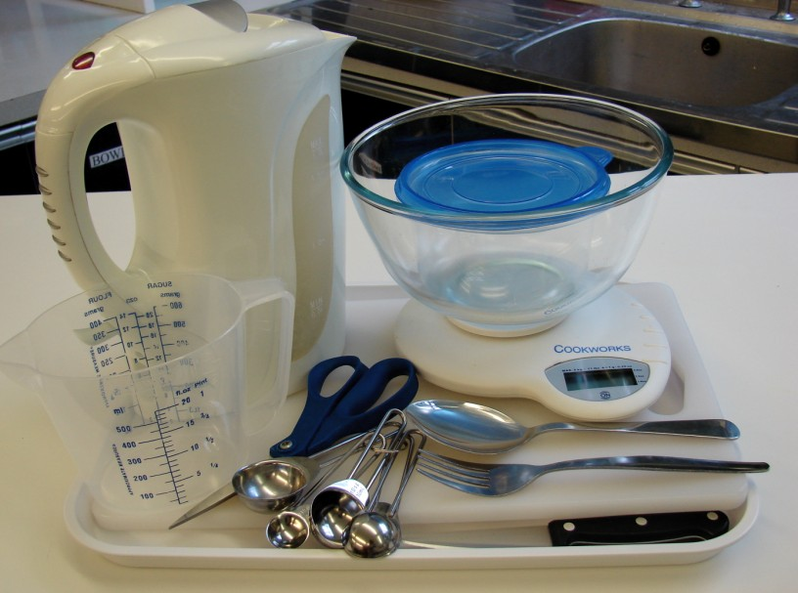
Kettle, measuring jug, measuring spoons, weighing scales, large bowl, fork, chopping board, sharp knife, can opener, scissors and mixing spoon.

Layered pasta salad

Weighing scales, saucepan, chopping board, knife, vegetable peeler, grater, measuring spoon, colander, serving dish.

Containers

If students take their salad home, they will need to bring (or be provided with by the school) a suitable container, such as a plastic tub or foil container with a lid.

