Pleasing pasta
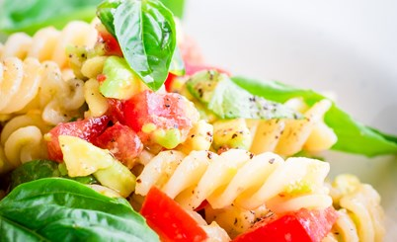

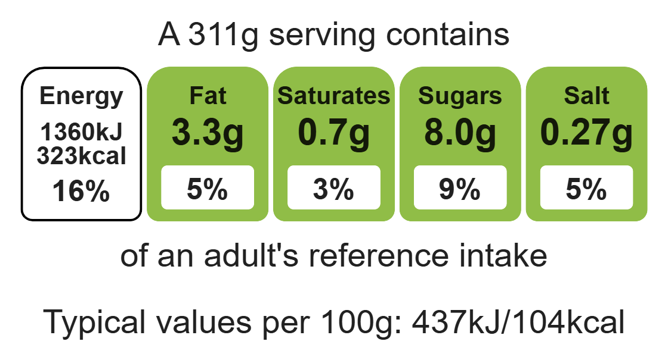

Ingredients (serves 2)

2 spring onions

4 x 15ml spoon sweetcorn (drained)
Complexity: low - medium

1/4 cucumber

200g can mixed beans

Equipment

Weighing scales

Chopping board

Kitchen scissors or sharp knife

Measuring spoons

Can opener

Sieve

Fork

Mixing bowl

Mixing spoon

1 can tuna (in water)

200g wholemeal pasta

1 x 15ml spoon reduced-fat dressing

A few sprigs of fresh coriander

Method
1. Prepare the vegetables:
- snip the spring onions, using scissors;
- drain the sweetcorn;
- chop the cucumber into small pieces;
- open, drain and rinse the beans in a sieve over the sink.
2. Carefully open and drain the tuna. Place in a small basin and break up gently with a fork.
3. Place the vegetables, beans, tuna and pasta in a large mixing bowl.
4. Pour over the dressing.
5. Stir everything together.
6. Snip coriander over the salad, using scissors.
7. Serve.

Top tips
- Reduce food waste: Use different vegetables or fruit, e.g. French beans, mango.
- Vary your protein: Add strips of cooked chicken, ham, beef or cooked prawns.
- Turn up the flavour: Why not try different herbs or spices such as basil or paprika?

Food skills
Weigh, measure, cut, chop, slice, dice and trim, drain, mix, stir and combine.

