African cuisines – a brief overview

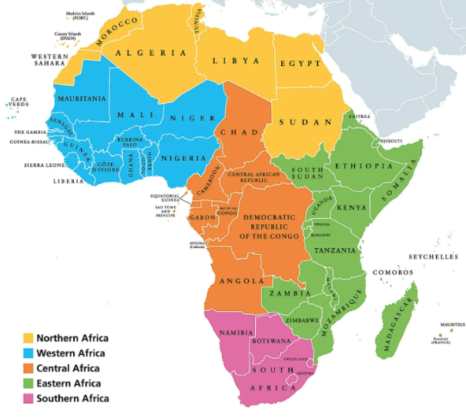
- The African continent has 54 countries that all have their own unique culture and food somewhat determined by the geography and climate of the region. The cuisines can be very broadly grouped into Central, Eastern, North, South and Western.
- Traditional African dishes typically has fish, meat, starchy foods (rice, plantain, yam cassava), and a wide variety of herbs and spices.
- In the colonial period, West African peoples were trading regularly with Europe and the Mediterranean, exporting cotton and precious metals in return for resources from the New World. For example, European explorers introduced tomatoes, chillies and peanuts to West Africa, and in turn, they took rice, black-eyed peas, okra and other ingredients back with them.
- The influence of West Africa on food around the world is clear. Rice, black-eyed peas and okra are staples in West Indian cuisine. In the American Deep South, Creole classics like gumbo, yams, greens and red rice are directly inherited from West African dishes, a result of the slave trade which took millions of West Africans over to America.
Central Africa
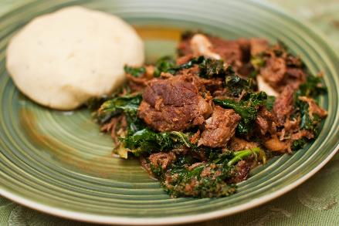
Central African cuisine is diverse as it comes from different traditions and culture. The cuisine is influenced by Portuguese and the Swahilis, a culture that is a combination of Yemeni, Bantu, Omani, and Indian.

Fufu is a popular side dish eaten with stews and soups. Fufu is made from cassava, which is also known as yuca. It is a starchy root vegetable, like sweet potatoes and yams. It is known as a ‘swallow food’ as it is used to scoop up the soup or stew and then swallowed!

Eastern Africa
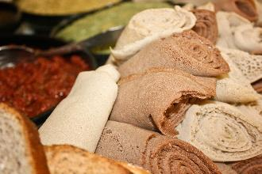
East African cooking tends to focus on grains, slow-cooked stews, curries and dairy, which are (especially in the Horn of Africa) flavoured with a variety of spices and spice mixes due to the Arabian influence from countries like Yemen, Oman and Egypt to the north as well as the Indian connection to the east.

A popular dish from Ethiopia is Injera, a fermented flatbread made with teff flour which is spongy, slightly sour and used as a sort of scoop to pick up other foods.

One popular snack that’s found throughout East Africa is sambusa, which looks like the Indian samosa but is filled with minced meat (sometimes fish), lots of chilli and spices. Halva is also served as a sweet treat during religious or celebratory occasions, as are many other sweet cakes.

Ugali is popular in the region and is a porridge type dough made from maize, cassava, sorghum or millet, served with a dry spiced curry of meat, fish or vegetables.

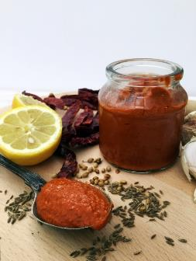
North Africa
The countries of north Africa have their own culinary traditions but also share many common ingredients. North Africa lies along the Mediterranean Sea and the cuisine has been influenced by traders, invaders and travellers over the centuries. The staple foods are seafood, meat (beef, lamb and goat), as well as fruits, vegetables, dates, and olives.
Ful medames is the national dish of Egypt and a common street food in cities like Cairo and Giza. It is also served in much of North Africa and the Middle East. Ful medames is a dish of fava beans, cooked in a pot and then served with vegetable oil and cumin, garlic, onions, peppers and hard-boiled eggs.

South Africa
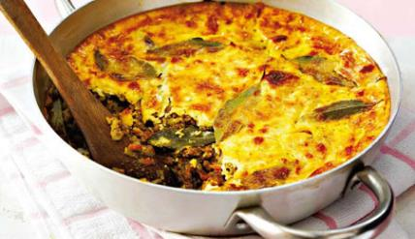
South African cuisine reflects the wide range of culinary traditions that were brought by the inhabitants that have lived in the region over the centuries. Dutch and British influences can be seen together those from Indonesia, Malaysia, Madagascar (Cape Malay) and India to create a culinary ‘fusion’ of ingredients and flavour.

Bobotie, thought to have been brought to South Africa by Asian settlers and is now the national dish of the region and country. Minced meat is simmered with spices, usually curry powder, herbs and dried fruit, then topped with a mixture of egg and milk and baked until set.

West Africa
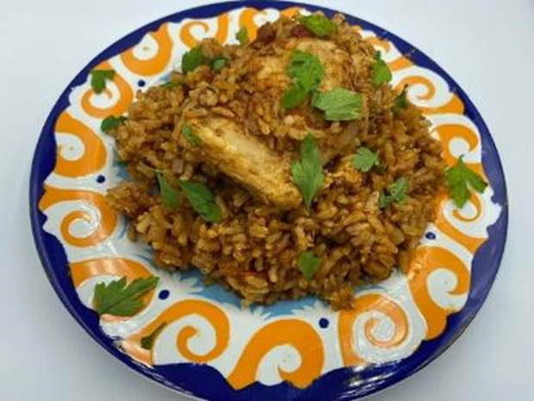
There is a diverse range of food and historical influences in the 16 countries that make up West Africa. European traders and explorers brought different food such as chili peppers, corn and tomatoes to West Africa and they became part of the cuisine along with staples such as cassava, peanuts, plantains and black eye peas. Although there are differences in counties the use of tomatoes, onions and chili peppers as a base for many dishes is common. Spices and herbs are used less in West Africa, but the chili pepper is very popular!

Groundnut stew (Maafe) is a popular peanut-based stew common to much of West Africa. Recipes vary but it is based on the base of tomatoes, onions and chili peppers with the addition of groundnuts (peanuts) and is traditionally served with rice, couscous or fufu.
Jollof rice (Benachin) is popular all over West Africa having originated in Senegal. There are many recipe variations, but it is based on rice, tomatoes and tomato puree, onion, salt, and red pepper.

Ingredients that are popular in African cuisines:

- Teff: Is a fine grain that comes in a variety of colours, from white and red to dark brown. It is an ancient grain from Ethiopia and Eritrea, is the staple grain of their cuisines. Ground into flour, teff is used to make the traditional bread, Injera.
- Harissa: Spicy roasted red pepper paste, flavoured with garlic and caraway.
- Preserved lemons: Made by fermenting whole lemons in lemon juice and salt, often added to tagines, salads, and soups.
- Chermoula: Chermoula is a sauce that can be used as both a marinade and a condiment. Chermoula varies regionally but often includes garlic, coriander, ground chili pepper, cumin, black pepper, and preserved lemons or lemon juice.
- Couscous: Made from crushed durum wheat, semolina flour, and water shaped into small granules.
- Ras el Hanout: This North African spice blend means “head of the shop” and is popular in Algeria, Morocco, and Tunisia. It is used to flavour lamb, game, and other North African foods typically served with couscous. It can have about 30 different ingredients, including ground coriander, allspice, cumin, cardamom, cinnamon, fenugreek, grains of paradise, cayenne pepper, nutmeg, turmeric, paprika, ginger, rose petals, and oregano.
- Dukkah: Dukkah means “to pound” in Arabic. It is a spice mix of sea salt, sesame seeds, coriander seeds, cumin seeds, and hazelnuts. Dukkah is often served with bread and olive oil.
- Grains of paradise: The glossy brown seeds of a reedy plant from the ginger family native to western Africa. Woody, floral, and slightly spicy, grains of paradise are related to cardamom but often used like black peppercorns for seasoning.
- Grains of Selim (also known as uda pods): Seed pods from a rainforest tree. In West African cooking they are often crushed and put into stews to give a deep, musky flavour
- Peri-peri: A traditional African sauce made from spicy African Bird’s Eye chili peppers. It is also known as piri piri, or pili pili. It is made from African Birds Eye peppers, garlic and herbs.
- Black eye peas: A type of legume. They are actually a bean, not a pea. They are related to cowpeas, or goat peas. Historically, they originate in West Africa, but they grow in warm regions around the world. They are available canned or dried.
- Cassava: A long tuberous starchy root. It is eaten mashed, added to stews, and used to make bread and fufu. Other names for cassava are yuca, manioc, mandioca, casabe, and tapioca. Cassava must be cooked or pressed before it's eaten, as it is poisonous in its raw form.
- Tamarind: Indigenous to Tropical Africa and is both a sweet and sour spice that can be added to many recipes.

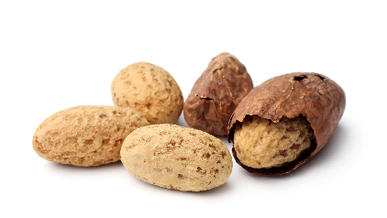
Did you know? The kola nut, which originated in West Africa and arrived in America via West African enslaved people, who used them to make stale water drinkable on the long voyage across the Atlantic. The kola nut went on to become a key ingredient in Coca-Cola and other energy drinks. Each nut contains more caffeine than two large cups of coffee.

