What is it? cards
These cards comprise images of equipment, name labels and descriptions of the equipment functions. These can be cut out and matched. The function cards can be removed to make the game easier if required.

Chopping board
Kitchen scissors
Grater
Peeler
Mixing bowl
Cutters
Weighing scales

Mixing spoon
Vegetable knife
Measuring jug
Measuring spoons

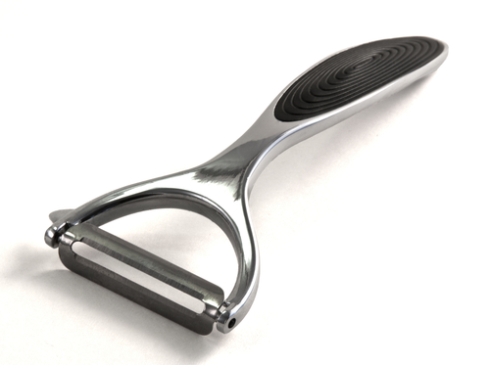
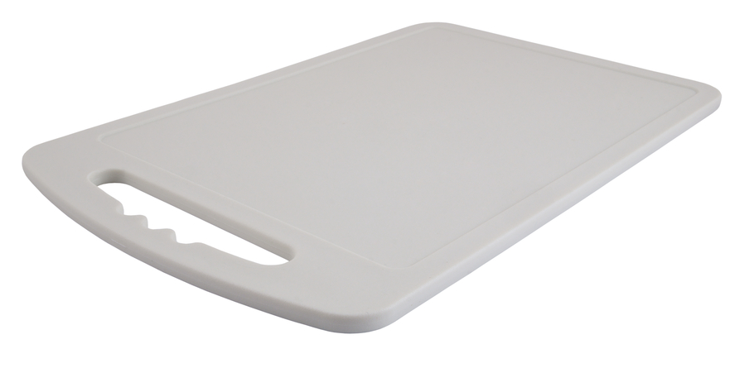

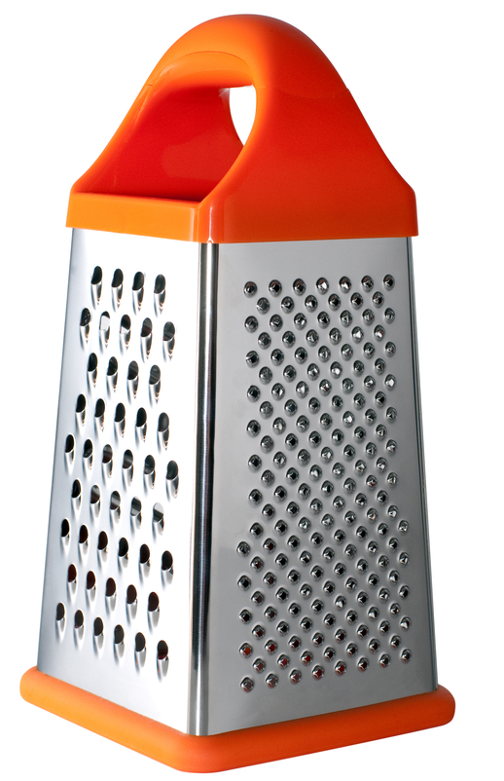
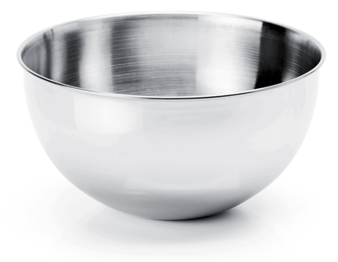

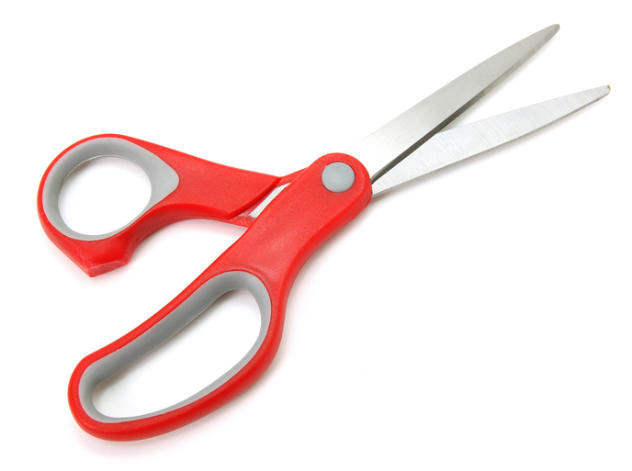
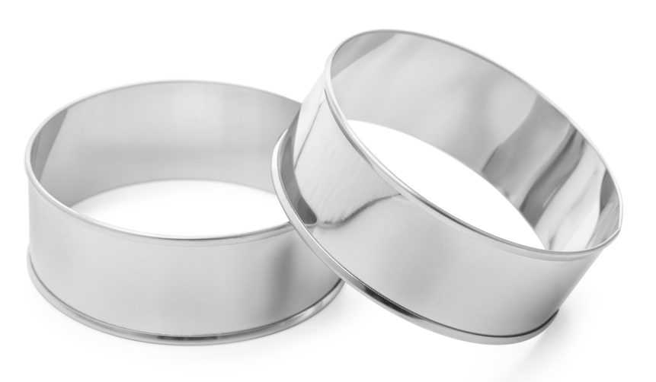

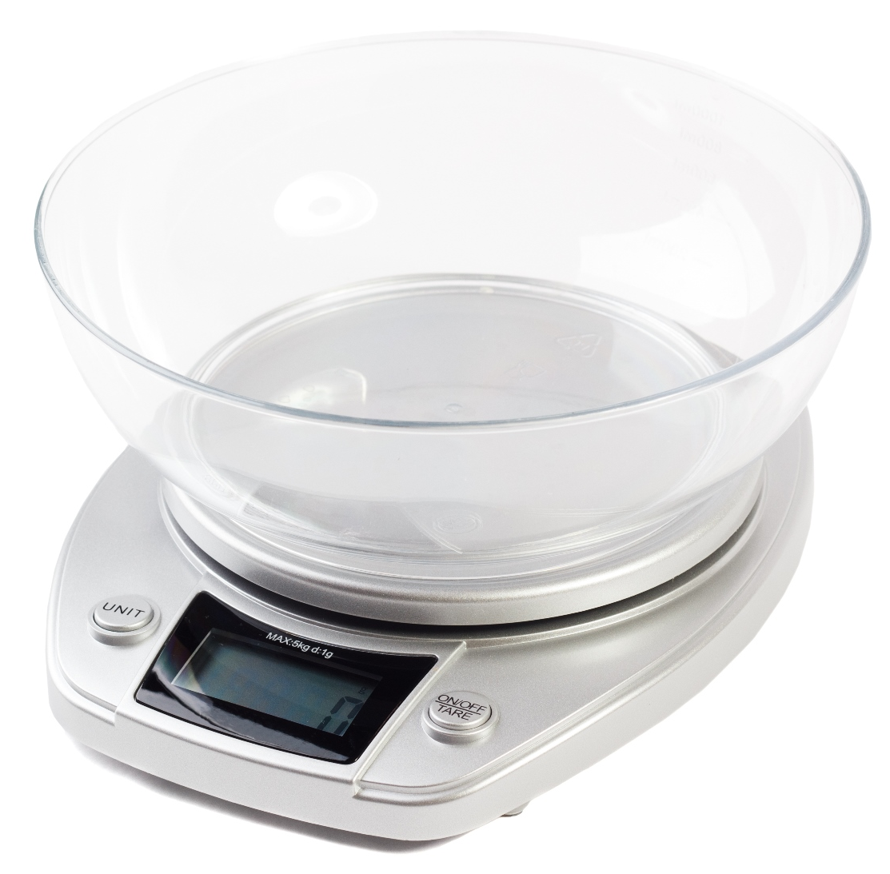
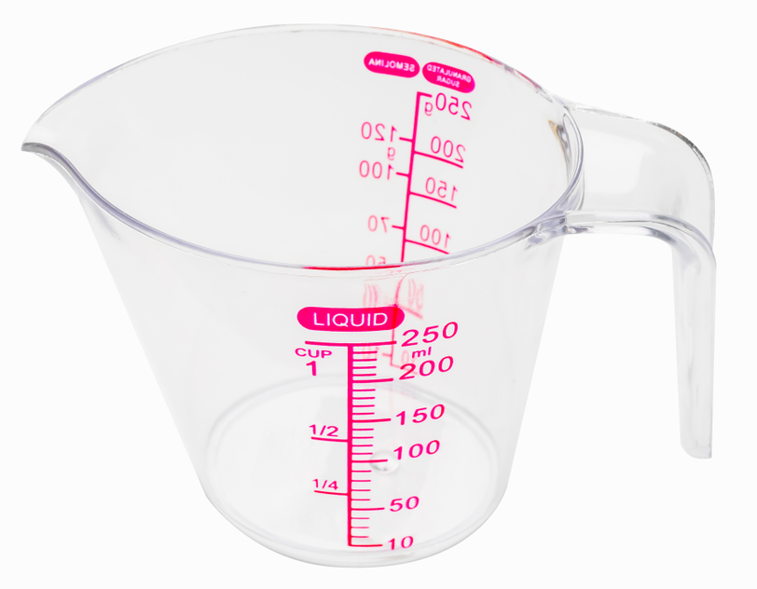

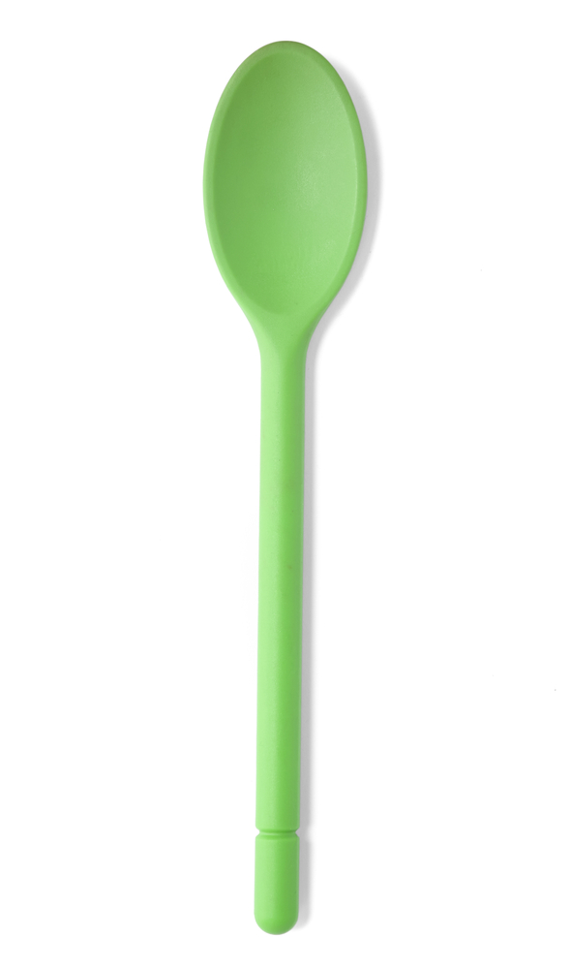

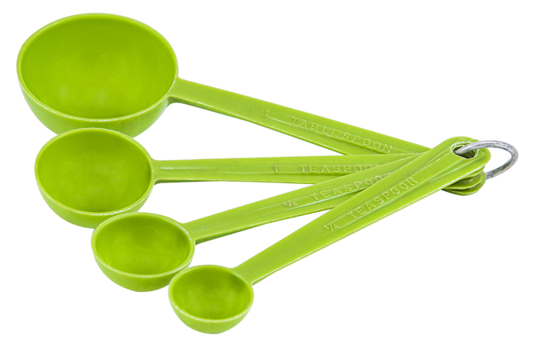

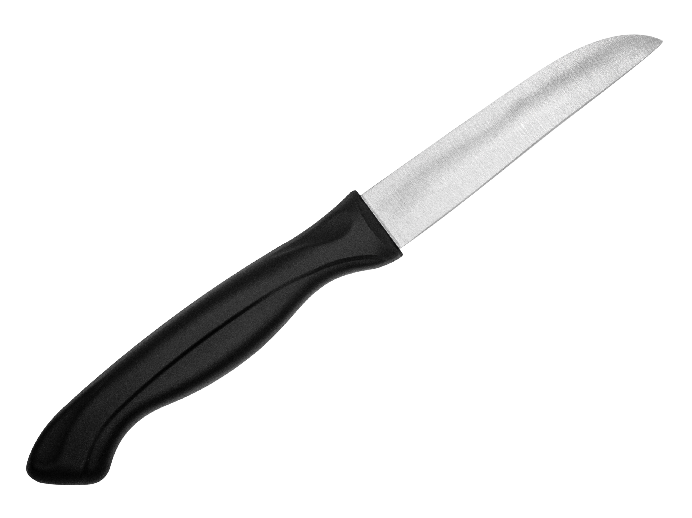

For measuring the weight of ingredients like flour.

For cutting ingredients into circles.

For resting ingredients on while they are being cut.

For grating ingredients like cheese and carrots.
For snipping ingredients like herbs and spring onions.

For measuring small amounts of ingredients.
For holding ingredients while they are being mixed together.

For taking the skin off food like carrots and potatoes.
For measuring ingredients like water and milk.

For stirring ingredients.
For cutting vegetables.

