Sustainable healthy food pick and mix

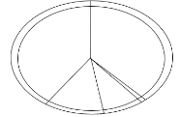  Build your own Eatwell Guide!  Using our blank Eatwell Guide template, fill in the different parts of the Eatwell Guide with the foods you would expect to find there.  Find images in magazines, online or draw your own.  Are any of the foods produced locally to where you live? | 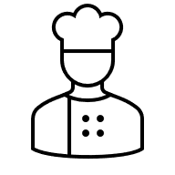  Create a healthy recipe.  Your task is to create a healthy recipe using an ingredient from the four main food groups on the Eatwell Guide. Think about the size of each food group. Make sure you include plenty of vegetables and starchy foods like pasta or rice!  Following the Eatwell Guide can ensure that it is a sustainable and balanced meal. |   Food cultures are moving and are no longer limited by origin. They can be spread far and wide by travel.  Create a global passport, on each page of the passport choose a different country and a popular recipe from their food culture.  Consider the Eatwell Guide when picking each recipe. How does the Eatwell Guide fit with food from around the world?
  Get portion wise.  Eating foods in their correct portion sizes can help to reduce food waste and eat in a more sustainable way.  Design a poster showing the correct portion sizes of different types of food.  Use this portion size information to help you get started. |   Superfood Heroes!  Sustainable, healthy foods can help provide nutrients to keep our bodies healthy.  Pick three “superfoods” which can help our bodies stay healthy. Create a superhero character for each “superfood”.  For each superfood hero, make sure you list their nutrients which help our bodies and which diseases they can help fight off. |   The Eatwell Guide shows us how to eat in a way that’s good for the planet and healthy for us.  But not everyone follows it. If more people did, we would be healthier and help protect the Earth too!  Pick five of your favourite evening meal recipes and change them to be more sustainable. Try adding beans and pulses to the recipes and choose one seasonal food or local food for each meal.
This resource meets the Guidelines for producers and users of school education resources about food.

