Tropical granola bars
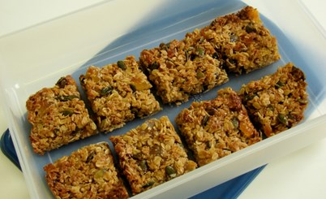

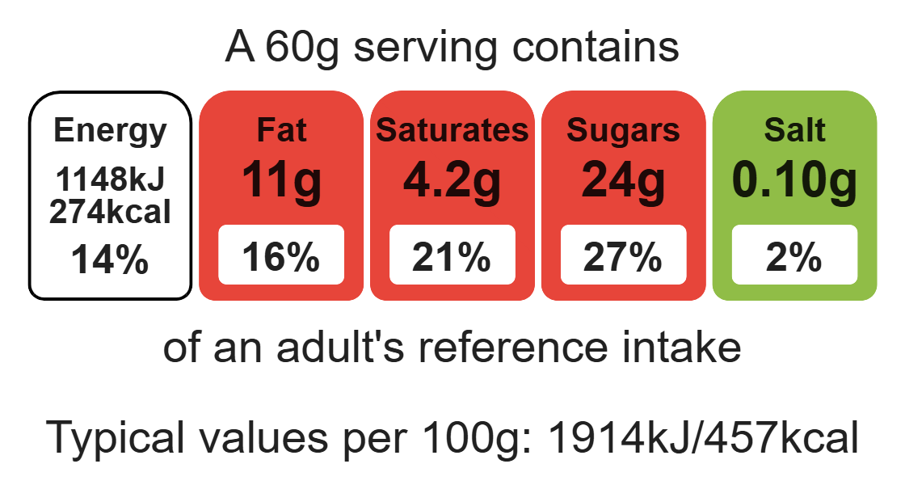

Ingredients (makes 8)
50g reduced-fat spread
Complexity: low - medium
2 x 15ml spoon honey
100g sugar

Equipment

Baking tray

Weighing scales

Saucepan

Heat-reistant spoon

Spatula

Palette knife

150g oats
1x 5ml spoon cinnamon
40g pumpkin seeds
40g desiccated coconut
75g tropical dried fruit

Method
- Preheat the oven to 160ºC or gas mark 4.
- Grease or line the baking tray.
- Sift the flour into the mixing bowl.
- Add the coconut, oats, and sugar into the mixing bowl and mix well.
- Melt the golden syrup and fat together on a low heat in a small saucepan.
- Mix the bicarbonate of soda with the boiling hot water and add to melted syrup and fat immediately.
- Add the wet mixture to the dry ingredients.
- Mix thoroughly until combined.
- Divide the mixture evenly into 8 portions using the metal spoon.
- Use lightly floured hands to shape the biscuits into round balls and place onto the prepared baking tray.
- Slightly flatten the biscuits with a lightly floured fork.
- Bake for 15-20 minutes, until golden brown.
- Cool on the baking tray for a few minutes, to allow the biscuits to firm, before transferring them to a cooling rack.

Top tips
- Turn up the flavour: Add 1 x 5ml spoon ginger or mixed spice to the oat mixture instead of cinnamon.
- Reduce food waste: Use up any leftover fruit such as sultanas, apple, banana or mango.
- Vary your protein: You could add a few chopped nuts- Be ingredient aware!

Food skills
Weigh, measure, melt, simmer and boil, mix, stir and combine, bake.

