Serving size problems front of pack nutrition labels
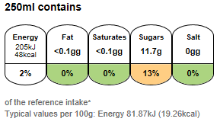
Regular cola (2 litre bottle, 250ml serving)
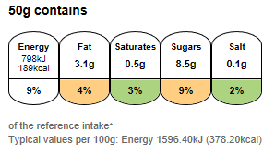
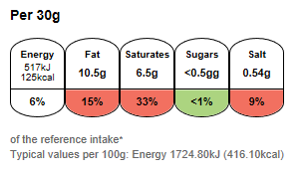
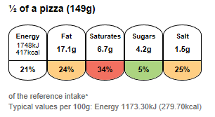
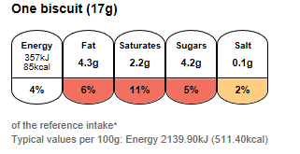
Half coated chocolate biscuit (17g per biscuit)
Thin and crispy meat feast pizza (300g, whole pizza)
Cheddar cheese (30g serving)
Swiss style muesli (50g serving)

