Food and drink I do and do not like
This is me.

Food and drink I like.

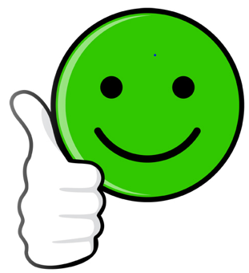

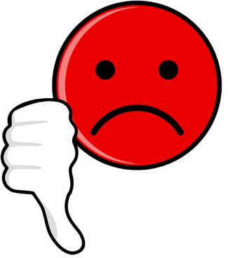
Food and drink I do not like.

