What we eat and when

Draw food and drink that people have for breakfast.

Draw the time people have breakfast on the clock.

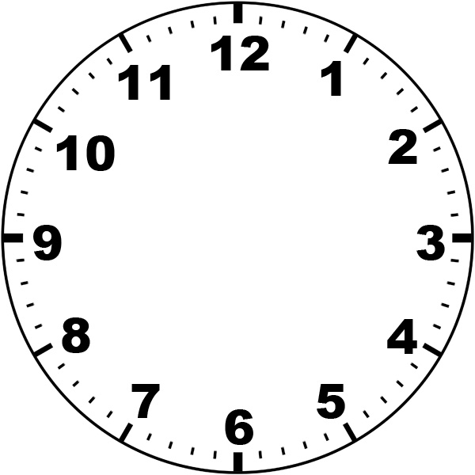

Draw food and drink that people have for lunch.

Draw the time people have lunch on the clock.

Draw food and drink that people have for an evening meal.

Draw the time people have an evening meal on the clock.

Draw food and drink that people have for snacks.

Draw the time people have snacks on the clock.

