Testing food for fat

Introduction
If a drop of liquid (such as alcohol, water or oil) falls on paper it makes a mark which is bright and translucent (lets light through) when the paper is held up to the light. With some liquids the mark disappears as soon as the liquid evaporates.

Alcohol takes a few seconds to disappear, water takes about a minute, but oil remains, forming a permanent grease spot.

In this way paper provides a method of distinguishing between oil and other liquids.

You will need
Equipment
Test tubes
Test tube rack
Glass rod
Spatula
Mechanical grinder or pestle & mortar
2 Dropping pipettes
Eye protection

Materials
Filter papers
Alcohol (ethanol)
Water
Oil e.g. cooking oil
Food samples
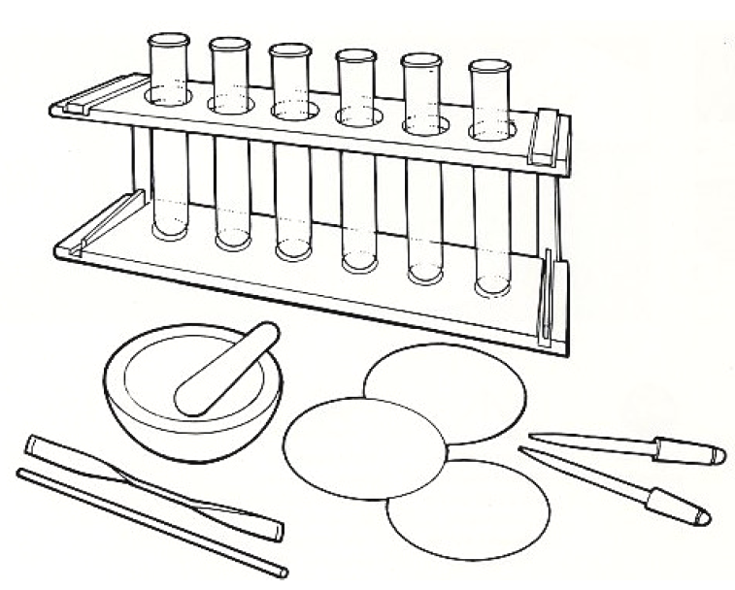

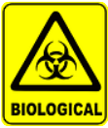
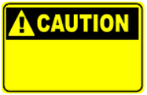

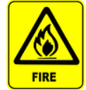

Some people are allergic or intolerant to a particular food or ingredient. Refer to the 14 allergens and check against student records before completing this experiment.

Do not consume food in a laboratory, or any food used for experiments, because it may contaminated.
Wear eye protection.
If alternative fat (grease) solvents such as proprietary brands of grease remover, are used all warnings on the bottle label should be carefully read and followed.
Alcohol (ethanol) is flammable. There should be no flames in the laboratory when this work is undertaken.

Method
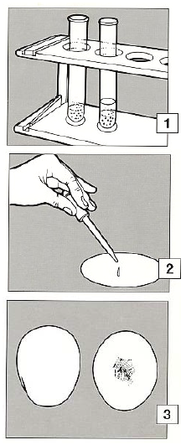
- If the food to be tested is liquid, go to 2. If the food to be tested is solid, make an extract. Grind, crush or chop a small amount and put it into a test tube to a depth of about 2cm. Add a similar amount of alcohol (ethanol) and stir with a glass rod. Allow to stand for several minutes.

- Draw up some of the clear liquid into a pipette and let a single drop fall on to filter paper. Using clean pipette, draw up a similar quantity from a fresh sample of alcohol and put a drop onto a clean part of the filter paper, or a new paper. Repeat with water.

The alcohol and water are control samples.

- Hang the papers up, open to the air. When the alcohol and water drops have disappeared examine the paper with the food extract on it.

If a translucent spot remains this indicates the presence of oil (or fat) in the food sample.

Extension work
Oils do not dissolve in water but form a cloudy liquid. This is called an emulsion. Make an extract from a food sample, as before, but at stage 2 put a single drop into a test tube half full of water and shake. Look to see if the water goes cloudy. An emulsion indicates oil in the extract.

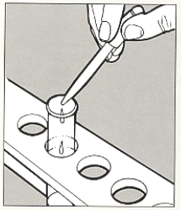
Without a substance called an emulsifier, the oil and water quickly separate again. Repeat the experiment adding a little mustard powder which contains an emulsifier. See how long it takes for the oil and water to separate.

