Dot-to-dot

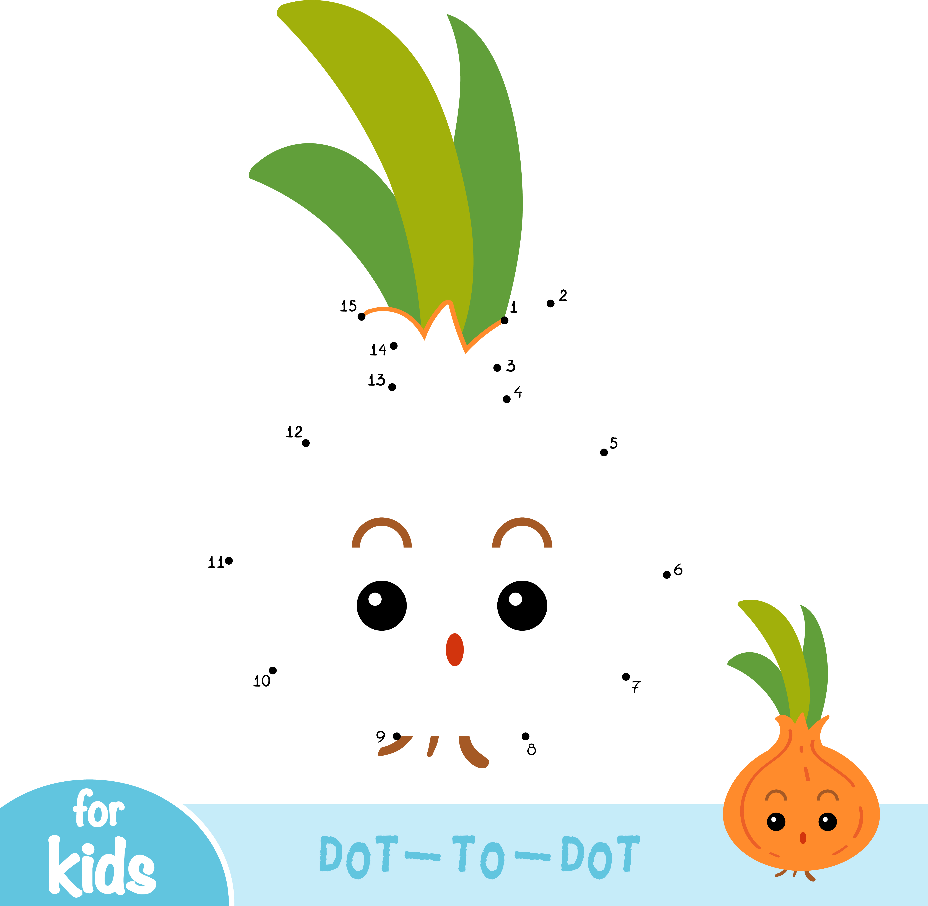
What is my name?

