What grows when?

Find out what fruit and vegetables are ready in different seasons.

Spring

Summer

Autumn

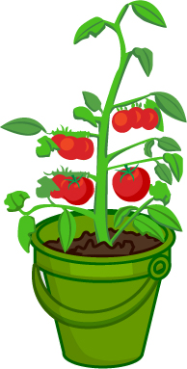

Winter

