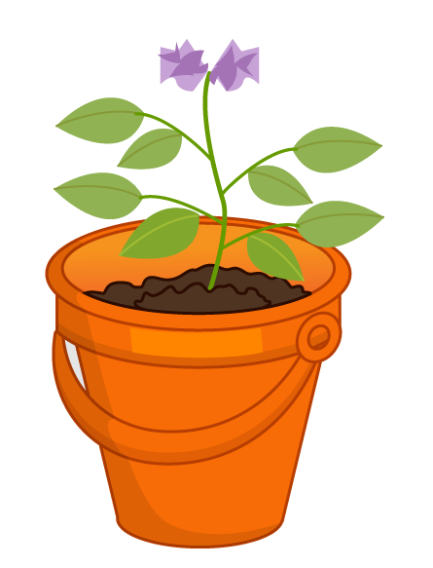
Growing a potato
Measure your potato plant once a week.

Date planted:__________________

Date harvested:________________

Week | Date | Height (cm)
1
2
3
4
5
6
7
8
9
10
11
12

