Harvest time
The bucket garden has been harvested!

Can you help Class B solve these problems?
There are 4 tomato plants.
Each plant has grown 5 tomatoes. How many tomatoes are there altogether?

There are 3 courgette plants. One grew 6 courgettes, one grew 7 courgettes and one grew 9. How many courgettes are there in total?


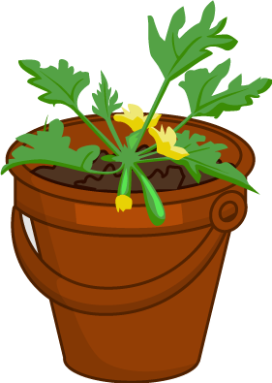

There are 20 students in Class B and 60 potatoes.
How many potatoes can each student have?

18 strawberry plants were grown.
2 got knocked over and damaged during the holidays and 3 plants died.
How many plants were left?

