
How to grow a potato

Equipment:
- 1 seed potato (potato which is starting to sprout);
- 1 x egg box;
- Hammer and nail – ADULT USE ONLY;
- 1 x bucket (with diameter of less than 50cm);
- A trowel;
- Compost or soil.

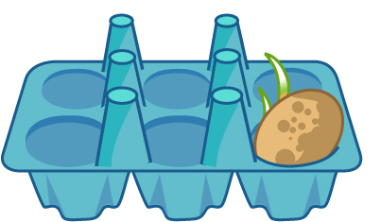
Put your seed potato into an open egg box with the sprouts facing up. Place on a windowsill for two weeks to allow the sprout to harden. This process is called chitting. This starts the growing process before planting.



Ask an adult to make a drainage hole in the bottom of the bucket, using a hammer and nail.

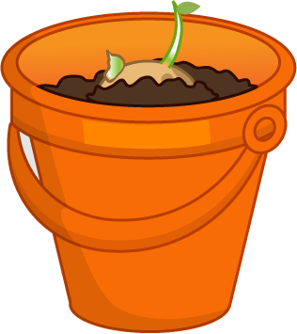
Once chitting is complete, add the compost or soil up to one-third of the bucket.

Place the seed potatoes in the bucket with the sprouts facing up.


Place the bucket outside where it can get plenty of light. Make sure the compost stays moist by watering it when needed. Top of with soil as it grows.

Fill the bucket to up two-thirds with compost or soil and pat down.

