Missing letter words
An apostrophe can be used to show that letters are missing in a word. Underline the words in these sentences which use apostrophes.

I don’t think we will be able to grow any potatoes after all.


I can’t see any potatoes.

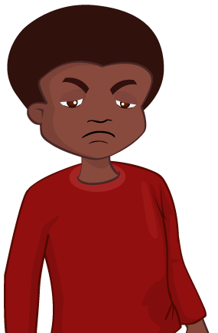

It hasn’t worked.


Let’s see.



We’ve got a garden now.

Fill in the chart with the words you have underlined.

Words with apostrophes | Written in full | Missing letters
don’t | do not | o
Word bank:
we have let us has not cannot

Find other words that use an apostrophe to show missing letters.

__________________________________________

__________________________________________

__________________________________________

__________________________________________

