Potato plant parts
Label the potato plant.

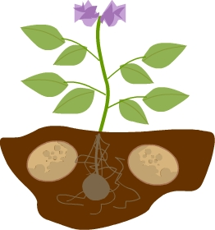

Word bank:

roots stem leaves flower tuber

