Spelling ‘oo’ words
How many ‘oo’ words can you spell?


B __ __ __
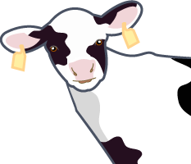
L __ __ __
Moo


F __ __ __

W __ __ __

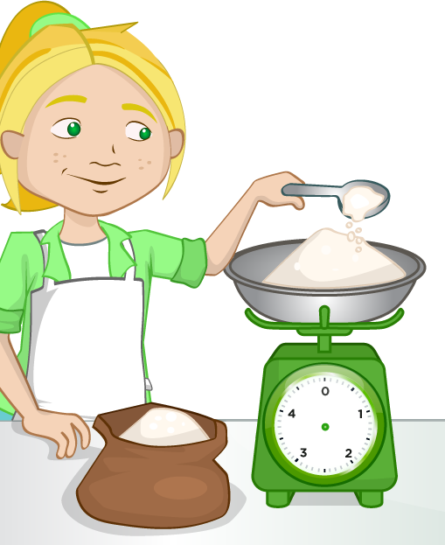

C __ __ __



B __ __ __

Can you think of any more ‘oo’ words?
_________________________________________________

