Super smoothie
Make a super smoothie for Grandma.
Choose 2 fruits.
I am going to use:

1) ___________________________

2) ___________________________

Ingredients
250ml milk
1 small pot fruit yogurt
Fruit

Equipment
Measuring jug, spoon, blender and 2 glasses.



Method
- Pour the milk in the blender.
- Pour in the yogurt.
- Add the fruit.
- Put the lid on the blender and switch on.
- Pour the smoothie into glasses.

Fruit ideas

Photograph of my smoothie


banana

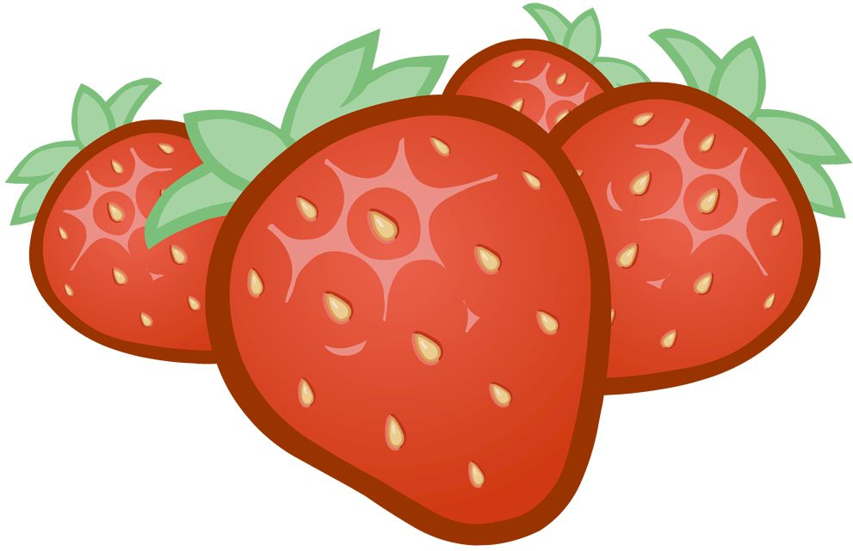
blueberries

strawberries


mango

