Thank you letter

Help Grandma write a thank you note.
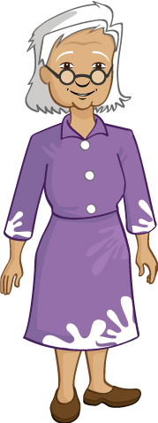

Dear Ronnie

