Writing names
Names start with a capital letter. Write down who you can see here.


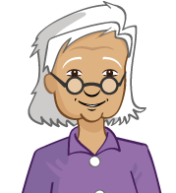

Name bank:

alisha

ronnie

grandma

Write your name:

_____________________________ .

Write your friend’s name:

_____________________________ .

Write your teacher’s name:

_____________________________ .

