Feeling good!
Fill in the missing words.


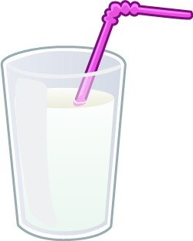
Milk is a healthy choice for my t _ _ _ _ .

Milk is a good drink after p _ _ _ .

Milk helps make my _ _ _ _ _ strong.

It helps me _ _ _ _ .



Word bank

bones

grow

play

teeth

