
On the dairy farm
Answer the questions below.
- Where do the cows live?

- What do the cows eat in the summer?

- How much water does each cow drink?

- What is silage?

- How often are these cows milked?

- What happens to the milk?

My cows live in a shed and are free to roam around. They enjoy going outdoors in the summer, eating the grass and taking exercise. They each drink about 55 litres of water a day.

In the winter, they stay inside because of the bad weather. They are still free to walk around. At this time of year they eat silage. Silage is preserved grass or maize.

My cows are milked twice a day. Milking doesn’t hurt the cows. The milk is gently squeezed from the udders. This is the same as a calf feeding.

The milk is cooled down to 4ºC and kept in a large tank. A large tanker comes to the farm to collect the milk. Some of my milk is put into bottles, and some is made into cheese and yogurt.

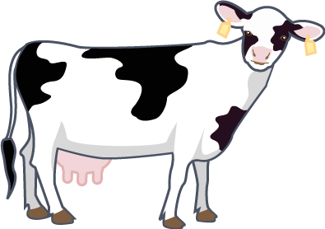

Mooo!

