Speech marks
Look at these parts of the story.
Rewrite the scene as text with speech marks.
Are they all made from milk?

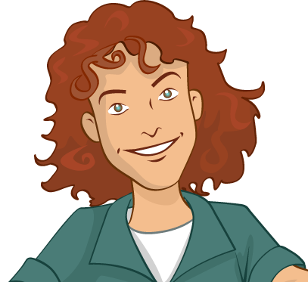
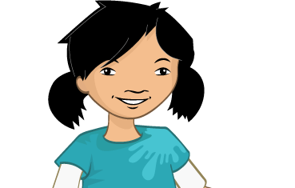

Well done, that’s right.

So, cheese comes from milk, and milk comes from cows?

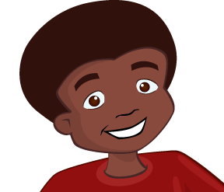

Correct!

