
What’s made from milk?
Task
Mr Valdez has set the class a challenge.
Find out the names of different types of milk, cheese and yogurt.
How many can you name?

Types of yogurt
Types of cheese
Types of milk

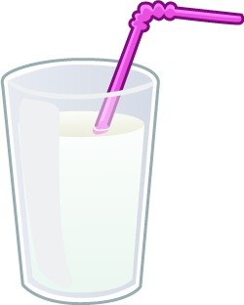
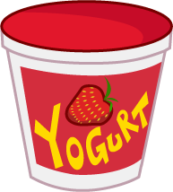
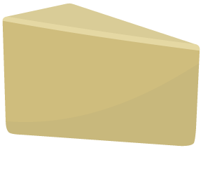

Task
What types of dishes can you make with milk, cheese and yogurt? Name 4 dishes.

