Write a thank you email
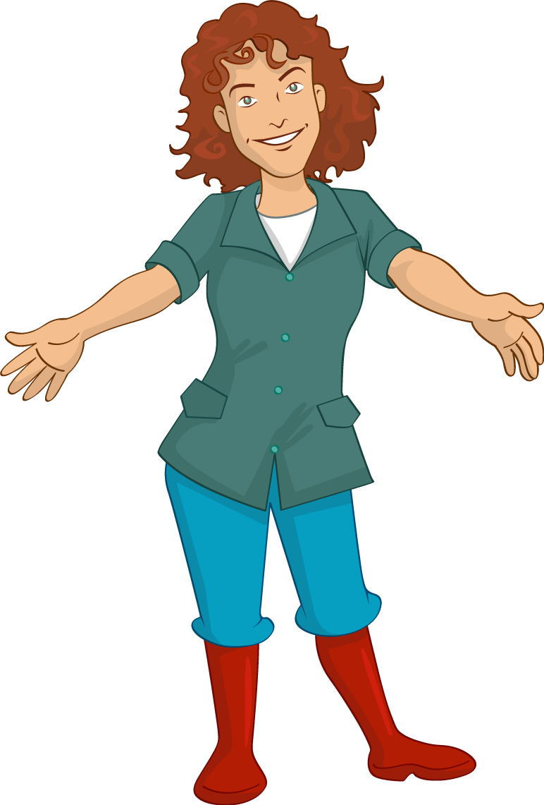
Write a thank you email to Mrs Jenkins from one of the characters in The Farm visit.

Who will you choose?
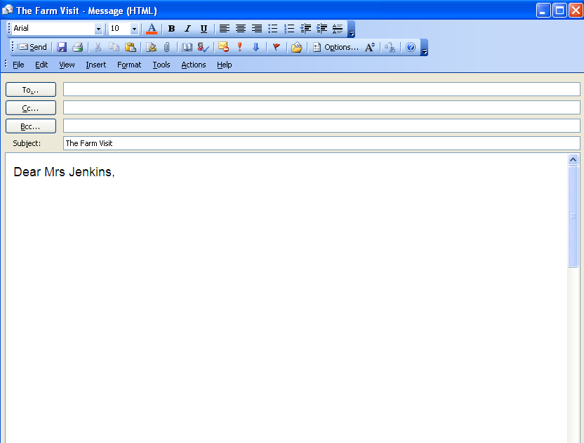

Remember to say thank you for everything that they saw and did on the farm visit!

