Cheesy maths
Did you know that 1000g = 1Kg?

Jordan has weighed 3 types of cheese.
Work out the cheese problems below.
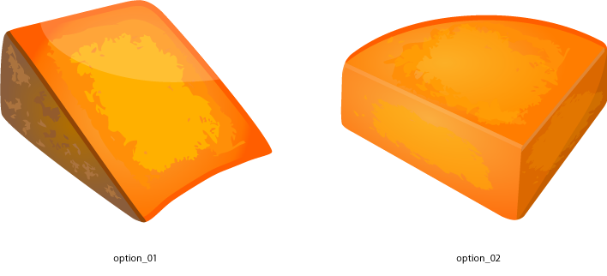
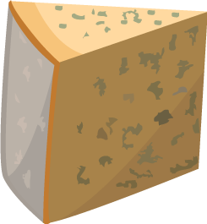


64g 125g 240g
1.  =  + | 6.  3  =  ÷
2.  =  + | 7.  =  +
3.  2  =  X | 8.  4  =  X
4.  =  - | 9.  ÷  2  =
5.  =  - | 10.  =  +

