Measuring
Each cow produces slightly different amounts of milk each day. Write the measure shown.

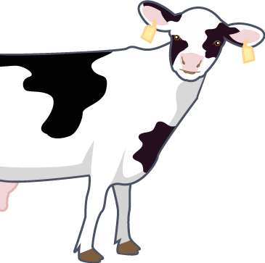  1.  25 L  20  15  10  5  0 | 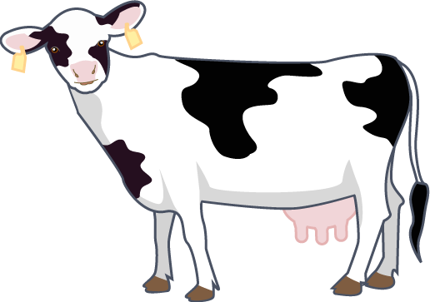  4.  25 L  20  15  10  5  0
2.  25 L  20  15  10  5  0 | 5.  25 L  20  15  10  5  0
3.  25 L  20  15  10  5  0 | 6.  25 L  20  15  10  5  0

Top tip!
You will need to estimate the amount if the line is between the numbers!

