Milking time
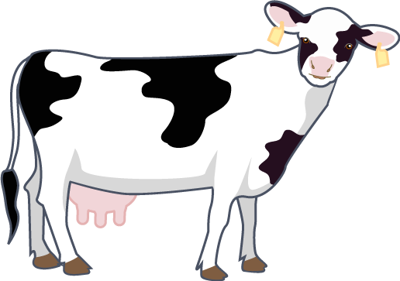
Cows like to be milked 2-3 times a day. Look at these clocks.
Is it milking time?

What times are the cows milked?

Write the times.

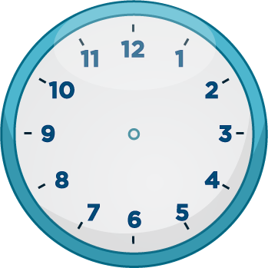


Mrs Jenkins has many jobs on her farm. Her watch is broken.
What time is it?
Draw the missing hands on the clocks so that she is on time!

Eat breakfast at 6:30am. | Answer emails at 8:10am. | Feed the cows at 1:45pm. | Plough the field at 4:25pm.

