Missing words
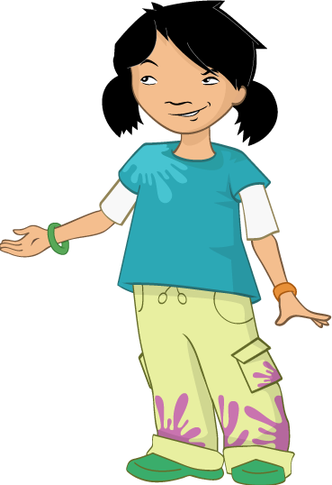
Look at these sentences from the story – there are words missing! Help Alisha find the missing words.
Which words should I choose?

“You can’t eat that!” said Alisha, “That’s for your lunch”.
Jordan didn’t listen and continued to look at his food.
Then, in one quick move, he stuffed a __________ and __________ roll in his mouth!
“Jordan! Stop being _________,” said Nicola.



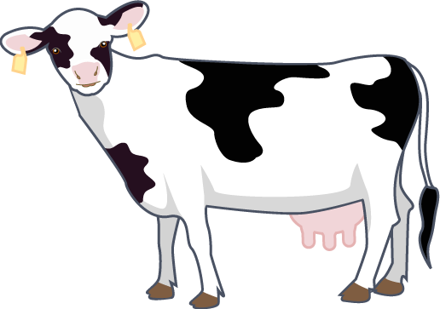
Mrs Jenkins led the children into the milking parlour.
The ________ were taking their places in the stalls.
“How do you get the _____ from the cow?” asked Alisha.
“That’s a ______ question, I’ll show you,” said Mrs Jenkins.

“Look!” said Jordan excitedly, “I can see milk going up that ______!”.
Jordan couldn’t believe his eyes. He had only ever seen milk in a plastic ________, never from a cow!
“How much milk do you think each cow makes in a day?” Mr Valdez asked the __________.



Word bank
cows water milk terrible good bottle jar
tomato pipe cheese tree greedy children

