
Converting units
1 kilogram (kg) = 1000 grams (g)
1 litre (L) = 1000 millilitres (ml)
Nicola is investigating units.
Convert these units.

1. Convert to ml:    1.6 litres | 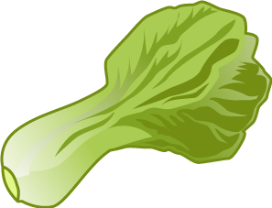  6. Calculate the total in grams.  0.5kg  450g
2. Convert to kg:    2800g |   7. How much soup is there in ml?  750ml  0.8L
3. Convert to g:    1.25kg |   8. What is the difference in grams?  950g  0.5kg
  4. Convert to litres:  330ml | 9. What is the total amount in L?  330ml  330ml  330ml
5. Convert to kilograms:    450g |   10. What is the total in kg?  50g  X 12

