
Drink plenty
To stay healthy and keep our bodies working well, we need to drink about 6-8 glasses of fluid a day.
Milk, water and fruit juice are popular choices!

Drinking plenty keeps us to stay hydrated.


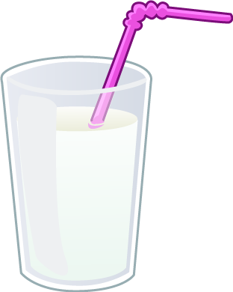

Being well hydrated helps our bodies and minds to work properly so we can concentrate, learn and be active.

Keep a drinks diary for a week.
List the different drinks you have.

 | 1 | 2 | 3 | 4 | 5 | 6 | 7 | 8
Monday

Tuesday

Wednesday

Thursday

Friday

Saturday

Sunday

