Food labels
Food labels can help us make healthier choices. They tell the energy, fat, saturates, sugars and salt provided by a food.
To make it easier front of pack labels are colour coded:
- Green = contains low amounts of the nutrient;
- Amber = contains medium amounts of the nutrient;
- Red = contains high amounts of the nutrient.

Next time you go food shopping, see if you can spot the food label on the front of the packet!

Part 1
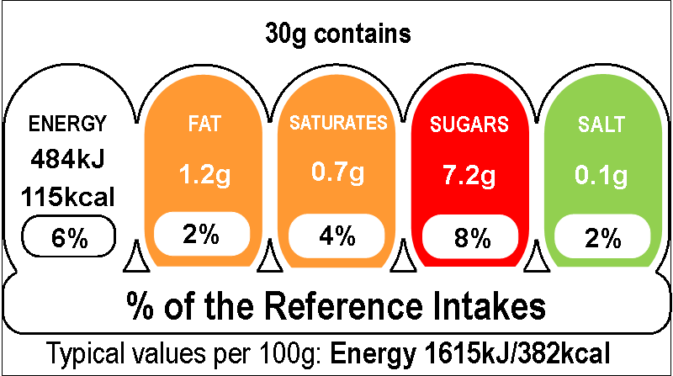
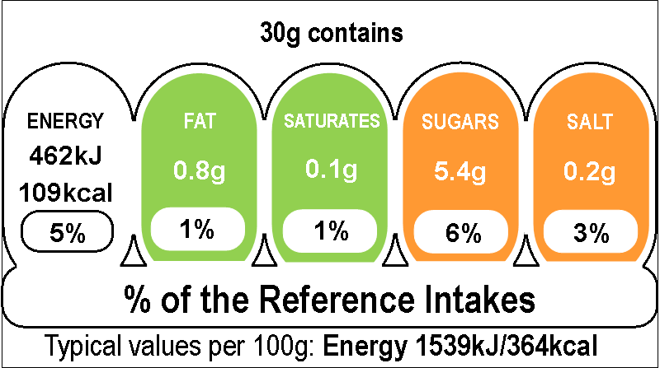
cereal A cereal B

- Above are food labels from two boxes of cereal.
Which cereal provides the most…
c) Fat?
__________________
d) Saturates?
___________________

- Sugars?
_______________________
- Salt?
_______________________

- Which cereal provides the least amount of energy?

- Which cereal would be the healthier option? Why?

Part 2

- A food manufacturer of bakery goods has forgotten to colour code their food labels. Using this table, colour in the food labels correctly.

 | Low (green) | Medium (amber) | High (red)
Fat | Less than 3.0g | Between 3.0g and 17.5g | More than 17.5g
Saturates | Less than 1.5g | Between 1.5g and 5.0g | More than 5.0g
Sugars | Less than 5.0g | Between 5.0g and 22.5g | More than 22.5g
Salt | Less than 0.3g | Between 0.3g and 1.5g | More than 1.5g

