Fractions
Alisha is sharing food for her class.
Calculate the fractions.

1.  of  1  3  9 French sticks =  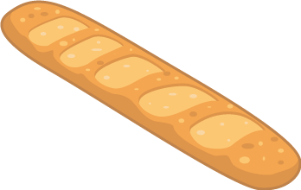 | 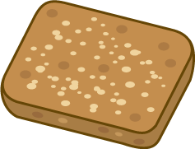  6.  of  2  4  40 flapjacks =
2.  3  8  of    24 bananas = |   7.  72 cheese portions =  of  5  6
3.  of  2  6  60 bread rolls =   | 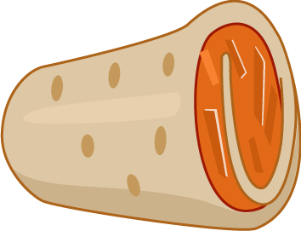  8.  196 wraps =  of  3  7
4.  3  5  100 water bottles =  of   | 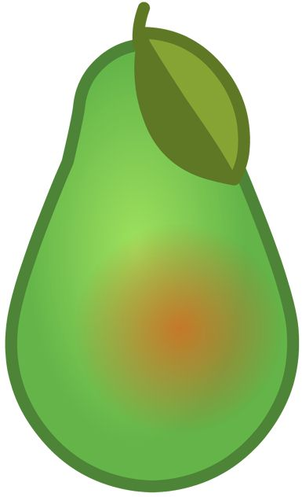  9.  300 pears =  1  5  of
5.  of  1  3  108 yogurts =   |   10.  165 carrot sticks =  2  3  of

