
Function junction

Mr Valdez loves multiplying and dividing.
Complete these lunchbox function machines.


1.
OUT =
22 = IN

Double


2.

Halve
OUT =
56 = IN


3.
OUT =
33 = IN

X 3


4.

÷ 5
OUT =
125 = IN

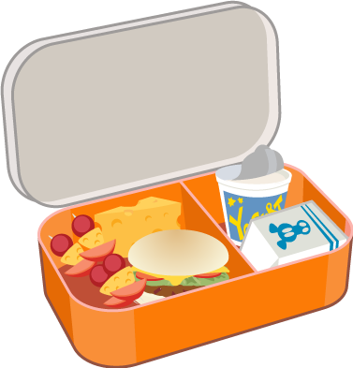
5.

X 6
OUT =
22 = IN

6.

÷9
OUT =
72 = IN

