Missing items

Lunchbox checklist
plenty of a starchy food, e.g. thick wholemeal bread, chapatti, pasta or rice salad
plenty of fruit and vegetables
some dairy and alternatives, e.g. individual cheese portion or pot of yogurt
some lean meat, fish or alternative, e.g. ham, chicken, beef, tuna, egg, hummus or bean/lentil salad
a drink

The four friends each want a healthy lunchbox.

What foods are missing from their lunchboxes?

Make other changes to make them healthier.

 |   
 |   
 |     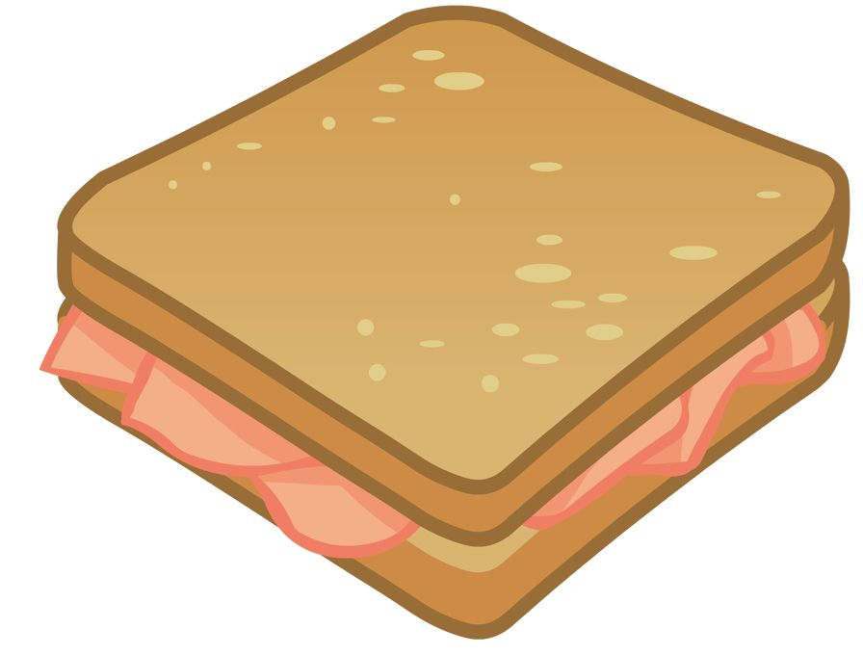
 |     

