Calcium calculations
Milk and dairy foods provide calcium, as well as other nutrients.
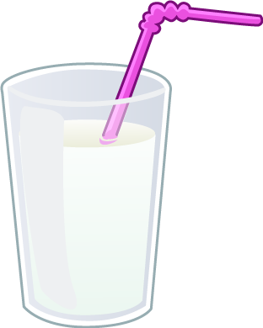
Calcium is needed for strong, healthy bones.

Name (per 100g) | Water (g) | Protein (g) | Fat (g) | Calcium (mg)
Skimmed milk | 90.8 | 3.5 | 0.3 | 125
Semi-skimmed milk | 89.4 | 3.5 | 1.7 | 120
Whole milk | 87.6 | 3.4 | 3.6 | 120
Low fat fruit yogurt | 78.9 | 4.2 | 1.1 | 140
Greek yogurt (plain) | 78.2 | 5.7 | 10.2 | 126
Cheddar cheese | 36.6 | 25.4 | 34.9 | 739


Look at the data and work out the calculations.
100g milk = 100ml
1. How much calcium is provided by a 200ml glass of whole milk? | 6. What is the fat content for 200ml of skimmed milk and 200ml of whole milk?
2. How much calcium is provided by 150ml semi-skimmed milk and 50g Cheddar? | 7. How much fat and calcium is provided by a 150g pot of each type of yogurt?
3. What is the difference in calcium between 100ml skimmed milk and 100g Cheddar? | 8. How much protein is provided by 150g Cheddar?
4. How much calcium is there in 1 litre of semi-skimmed milk? | 9. How much water is there in 1 litre of skimmed milk?
5. How much calcium is provided by 200g Greek yogurt? | 10. How much calcium is provided by 200ml semi-skimmed milk, 150g low-fat yogurt and 50g  Cheddar?

