Special bread
Bread is often linked to special occasions. Challah is a special Jewish bread.

Be a Food investigator and find out about Challah and two other special breads.

Name of bread | Image | Information
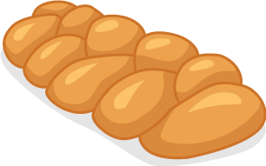
Challah

