How is cheese made?
Help Ronnie and Alisha explain how cheese is made.

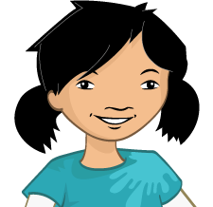  Alisha: | To make cheese, first, ______________ is added to milk. This causes it to separate into the watery ____________ and thick lumps, called ____________.  What happens next, Ronnie?
Ronnie: | Well, the _______________ is removed from the ____________, and is squeezed to remove all the ____________.
Alisha: | That’s right. Then some ____________ is added and it is all ____________ together and ____________ tightly.  Do you think this is ready to eat yet?
Ronnie: | Not quite, Alisha. The block is then left to ____________ so it becomes ____________.  Different __________________ can be added to give it different ________________.
Alisha: | Sounds exciting! Shall we go and explore different types of cheese next?
Ronnie: | Of course! Let’s go!

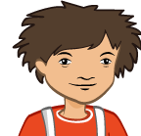
Word bank
rennet | water | wrapped
curds | salt | mature
whey | mixed | tasty
ingredients | flavours

