Milk production

Chik Chi and Yan want to know more about milk production in the UK. Complete the scrap book to give them as a present. Make it exciting!



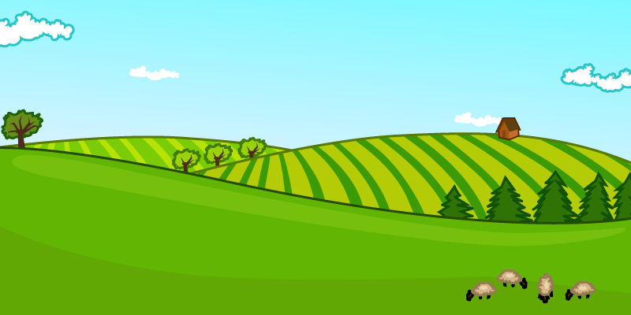
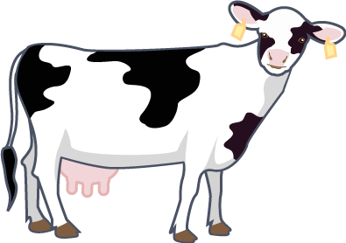

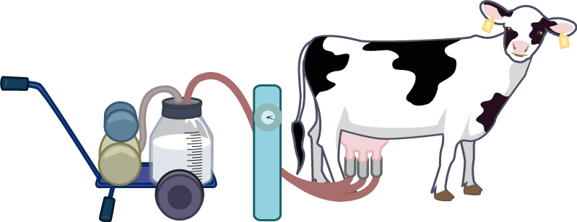

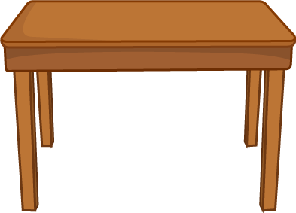
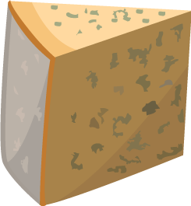
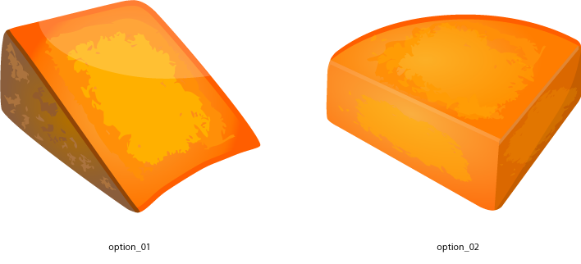





Milk production – support information

This is Mrs Jenkins, a dairy farmer from the UK.
Her cows live in a shed and are free to roam around.
The cows enjoy going outdoors, eating the grass and taking exercise.

Each cow drinks about 55 litres of water a day and eats between 25-50kg. The amount of feed a cow consumes depends on the breed, age and stage of milking.
In the winter, the cows stay inside because of the bad weather. They are still free to walk around. At this time of year they eat silage. Silage is preserved grass or maize.

On the majority of British dairy farms, cows graze outdoors during the summer and are housed during the winter. There are two main types of shed: loose housing in which they have communal laying areas and the free stalls system with individual bedded stalls. Both systems allow the cows to rest, stand or move around freely.

After milking, the milk is cooled down to 4ºC and kept in a large tank. A large tanker comes to the farm to collect the milk.

Some of the milk is put into bottles, and some is made into cheese and yogurt.

Most farmers milk their cows twice a day, but in a robotic milking system cows sometimes choose to be milked four to five times a day. Milking is not uncomfortable for them – this is the same as a calf feeding.

Milking does not hurt the cows. The milk is gently squeezed from the udders. This is the same as a calf feeding.

