Shapes

Miss McKay wears glasses which are an interesting shape.
Name the different shapes below and find an everyday example for each.

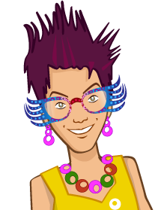

Word bank

Cylinder Triangle Pentagon
Pyramid Square Hexagon
Cube Kite Arch
Circle Trapezium Parallelogram

