The seaside adventure
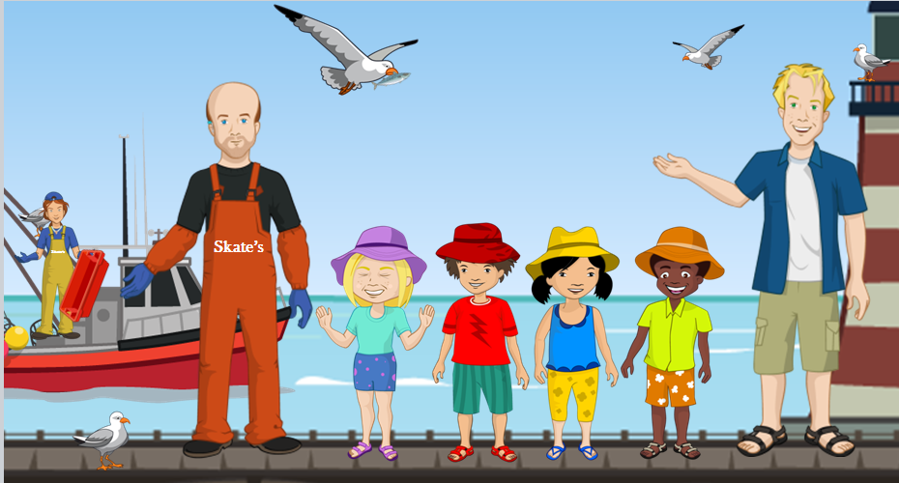

Summary: Alisha, Jordan, Nicola and Ronnie visit the seaside and learn about different types of fish and how they are caught.

Suggested age: 8-9 years old.

Key themes:
- The variety of fish and fish dishes.
- The journey of fish - from sea to plate.
- The importance of trying different foods.

Teacher notes:
- Read The seaside adventure story with your class. You could print the PowerPoint presentation and read it like a book, or show it on an interactive whiteboard.
- Show The seaside adventure video – this includes the audio for the book.
- Ask the children the Key questions to help them engage with the story.
- Use all or some of the resources to carry the Key themes across your curriculum.

Key questions:
Closed
- What type of shop does Mr Skate own?
- What time of day does Mr Skate go fishing?
- Where is the fish taken after it arrives at the harbour?
- Where does the fish go after it is sold at the market?
- Name three types of fish sold in Mr Skate’s shop.
- What fish dish does Jordan talk about when the children are talking about their favourite fish dishes?
Open
- Why do you think Nicola feels embarrassed when the other children are talking about their favourite fish dishes?
- Why do you think Nicola does not like fish?

Own experience
- Have you ever thought you did not like a food but changed your mind when you tried it, or tried it for a second time? Explain what happened.
- Which of the fish dishes in the story have you tried?
- What is your favourite fish dish?

The seaside adventure activity ideas
To support different aspects of the story, a set of cross- curricular/interdisciplinary resources have been developed. These are in addition to the PowerPoint presentation and the video of the story. The resources can be used as stand-alone materials, or combined together to support a longer unit of work. The choice is yours.

You may wish to download all the materials and upload them to your school VLE.

All the resources below (unless stated) have been provided in Microsoft WORD format, allowing you the flexibility to adapt the worksheets to better suit the needs of the children you teach.

Curricula links

Resources | England  Key stage 2 | Northern Ireland  Key stage 2 | Scotland  Second | Wales  Key stage 2
Mr Skate’s diary  Retell events from Mr Skate’s point of view | English - Year 3 and 4  Writing – composition  -draft and write by…organising paragraphs around a theme | Language and literacy  Writing  Write for a variety of purposes and audiences, selecting, planning and using appropriate style and form. | Literacy and English  Writing  LIT 2-28a | English  Writing  Range  Writing for a range of purposes, e.g. recount
Persuading Nicola  Writing a persuasive letter | English - Year 3 and 4  Writing – composition  -draft and write by…organising paragraphs around a theme | Language and literacy  Writing  Write for a variety of purposes and audiences, selecting, planning and using appropriate style and form. | Literacy and English  Writing  LIT 2 – 29a | English  Writing  Range  Writing for a range of purposes, e.g. persuade

Resources | England  Key stage 2 | Northern Ireland  Key stage 2 | Scotland  Second | Wales  Key stage 2
What’s the weight?  Read and identifying different weights on analogue scales | Mathematics – Year 4  Number – number and place value  -identify, represent and estimate numbers using different representations | Mathematics and numeracy  Handling data  Interpret a wide range of tables, lists, graphs and diagrams… | Numeracy and mathematics  Measurement  MNU2 – 11b | Mathematics  Measures and money  Range  Interpret numbers on scales and read scales to a degree of accuracy…
Measuring  Measure accurately in mm and convert the measurements into centimetres | Mathematics – Year 4  Number – number and place value  -identify, represent and estimate numbers using different representations  Measurement  -convert between different units of measure | Mathematics and numeracy  Measures  Appreciate important ideas about measurement including the continuous nature of measurement and the need for appropriate accuracy.  Understand the relationship between units and convert one metric unit to another. | Numeracy and mathematics  Measurement  MNU2 – 11b | Mathematics  Measures and money  Range  Choose appropriate standard units of length, volume, capacity…  Understand the relationship between units, and convert one metric unit to another.
Fishy dishes  Name four fish dishes and carrying out a survey to find out which is the most popular | Mathematics – Year 4  Statistics  -interpret and present discrete and continuous data using appropriate graphical methods, including, pictograms, tables and other graphs | Mathematics and numeracy  Handling data  Collect, classify, record and present data… | Numeracy and mathematics  Data and analysis  MNU 2-20b | Mathematics  Handling data  Range  Collect data for a variety of defined purposes…  Use and present data in a variety of ways.
A message to Mr Skate  Explore sign language - to download a British Sign Language Fingerspelling sheet, go to: http://www.british-sign.co.uk/british-sign-language-bsl/free-fingerspelling-chart/ | PSHE - Non-statutory guidance  Relationships  -learn that differences in people might arise from a number of factors including… disability | Personal development and mutual understanding  Understand that differences and similarities between people arise from a number of factors including cultural, ethic/racial and religious diversity, gender and disability. | Health and wellbeing  Metal, emotional, social and physic wellbeing  HWB 2 -10a | PSE  Active citizenship  Range  Develop respect for themselves and others.  Value diversity and recognise the importance  of equality of opportunity.
Fish fact file  A fold up booklet to encourage research about fish  This activity is only available as a pdf in order to ensure the formatting remains in position when it is printed. | English – Year 3 and 4  Reading - comprehension  -retrieve and record information from non-fiction | Language and literacy  Reading  Use traditional and digital sources to locate, select, evaluate and communicate information relevant for a particular task. | Literacy and English  Reading  LIT 2 – 14a | English  Reading  Skills  Read in different ways for different purposes…
Get cooking!
Why not help your class explore fish further by cooking some simple fish recipes?

You could try …
- Marvellous mackerel pate;
- Tantalising tuna wraps;
- Splendid seaside salad
- Fantastic fish cakes;
- Fancy fish fingers;
- Special smoked haddock samosas.

