
Fish fact file
Name: _____________________________
Date: _____________________________
Create your own fact file based on one of the fish mentioned in The seaside adventure story.

This fact file is about:

________________________

Fish families
Fish are organised into different families. Find some examples of fish that belong to these families. Can you find another fish family?
Family | Fish
Shellfish
Round white fish
Oil rich fish

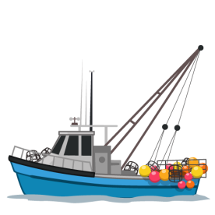
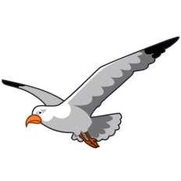
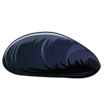
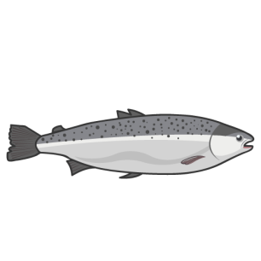
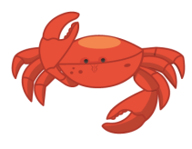
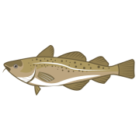
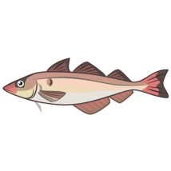
Key facts about __________________
Illustration:

Notable features:

- ___________________________________

- ___________________________________

- ___________________________________

Likes to eat:_________________________________
Full size:____________________________________

Life span:___________________________________

Usually live (type of water and position in the water, e.g. sea near the bottom):

Where can these fish be caught around the UK coast?

Amount caught each year
in the UK:
___________________________________

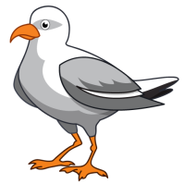
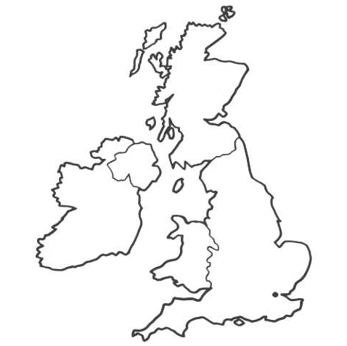
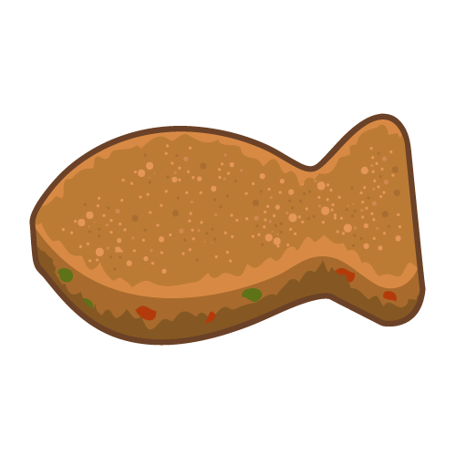
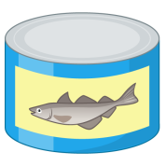
Fish dishes
Find four dishes made with your fish.

How is it sold?
List the different ways your fish is
stored in shops and draw how
it is packaged.
Stored, e.g. shelf, refrigerator, freezer | Packaged (can, vacuum sealed packet, box)

UK fishing
Label these fishing ports on this UK map.
Grimsby, Brixham and Peterhead. Can you add anymore?

Choose your favourite from the four dishes. Find a recipe for the dish and write the ingredients and method below.
Recipe:______________________________
Ingredients:

Method:

