Grain chain
Complete the following questions about The Grain Chain.

1. Name three countries where wheat is grown.
a)
b)
c)

2. What is the name of the quality mark used in the UK?

3. Complete this diagram of a wheat grain.
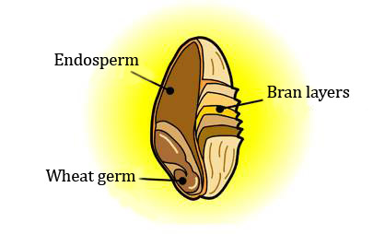

4. Where is white flour from on the grain?

5. How is brown or wholemeal flour made?

6. Complete this table about the different types of flour.

Flour type | Part of grain used

White

Brown

Wholemeal

7. On the back of this worksheet, draft a flow chart showing the main steps in making flour. Explain what happens at each step.

