Eat your veg!

Information for parents and carers of young children

Why do we need to eat vegetables?
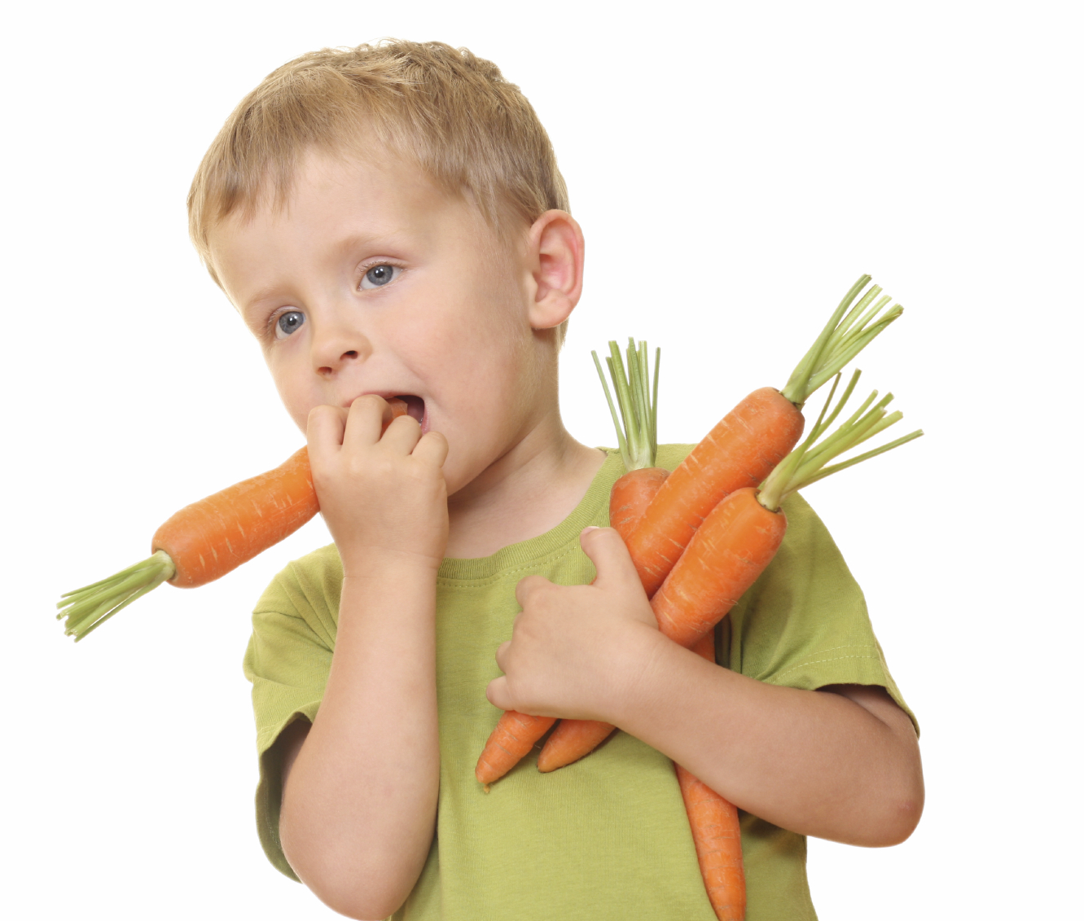
Vegetables contain vitamins, minerals and fibre. Vitamins and minerals have lots of different jobs in the body and we need them to stay well. Fibre helps waste food move through the body to keep our digestive system healthy. Different vegetables contain different vitamins and minerals and amounts of fibre - this is why it is important to eat a variety of different vegetables.

Why do children often refuse vegetables?

Young children are often naturally cautious about new food and it can take many attempts to get them to try something different. It can be even more difficult with vegetables because they are less sweet than fruit and some types, such as broccoli and cabbage, have a naturally bitter taste which young children are more sensitive to than older children and adults.

Why do we need to get young children to keep trying vegetables?
Eating habits developed at an early age can follow on into later life. This means that the preschool years are an important time for children to explore and experience a wide variety of vegetables (and other food) to set them on the right course for eating well as they grow up.

What can we do?

Although it’s not always easy, there are lots of things you can try that have been shown to help young children learn to like vegetables. Start by taking a look at our Learning to love vegetables information for some practical tips.

Helping your child become more familiar with different vegetables by looking at pictures of them, learning about how they grow and are served, can make them more likely to try and enjoy different vegetables. There are lots of activity ideas below that you can use with your child.

Activity ideas
- See and Eat ebooks – 24 colourful ebooks showing the ‘farm-to-fork’ journey for different vegetables.
- Veggie bingo – enjoy these six different vegetables with your child and colour in your bingo boards once you’ve eaten them.
- Veggie stories – turn these vegetables into characters and make up a story about them.
- Veggie taster – taste these six vegetables with your child and give them a smiley face rating.
- Veggie treasure hunt – next time you go shopping, hunt for these vegetables beginning with the letter ‘c’.
- Which veggie am I? – cut out and match these vegetables with their descriptions.
- Spot the veggies – look at these dishes and spot the veggies they contain.
- Veg and letter matching – match these vegetable pictures to the letters they begin with.

For more information about feeding preschool children, click here.

